Who Am I!
Who? | Facts & Information | Picture
Toussaint L’Ouverture |  | 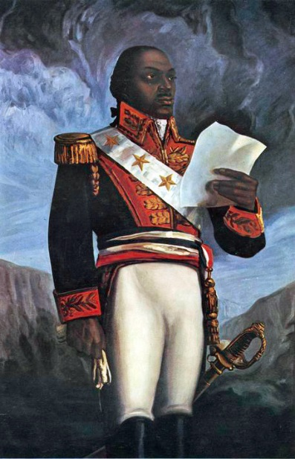
Simon Bolivar |  | 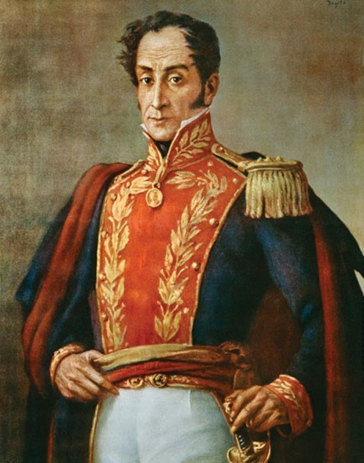
Miguel Hidalgo |  | 