Reproduction & DNA Study Guide
1. Sickle-cell anemia is an inherited disease that affects red blood cells. In people who have this disease, one amino acid is substituted for another amino acid in a blood protein. What causes sickle-cell anemia?
A. mutation
B. replication
C. translation
D. transcription

2. What is DNA?
A. a type of molecule composed mostly of amino acids
B. a type of molecule that performs the main functions of cells
C. a type of molecule that speeds up the rate of a chemical reaction
D. a type of molecule that determines the traits that an individual inherits

3. Proteins are responsible for many of our traits. How can a substitution mutation affect a person’s traits?
A. This mutation stops DNA from replicating.
B. This mutation prevents ribosomes from synthesizing proteins.
C. This mutation changes the number of chromosomes a person has.
D. This mutation causes a change in the protein that forms during translation.
4. What is the purpose of replication?
A. to make an RNA template from DNA
B. to produce copies of a DNA molecule
C. to move mRNA through the ribosome
D. to change the number, type, or order of bases in DNA

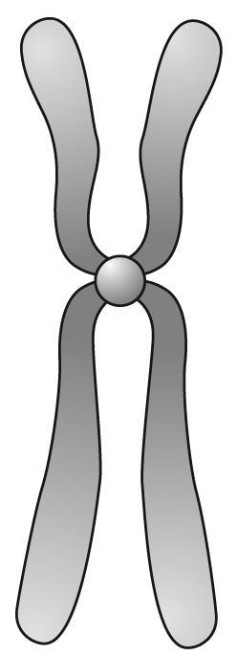
5. Terrie is making a model of DNA. Which of these shapes illustrates how her model should look?
A. B . C. D.
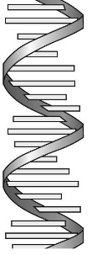
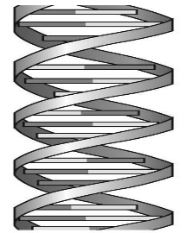
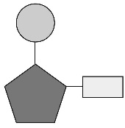

6. The shape of DNA
A. nucleotide
B. double helix
C. thymine
D. cytosine

7. one of the four possible bases in a string of DNA -it pairs with adenine
A. thymine
B. guanine
C. cytosine
D. sugar

8. a subunit of DNA that consits of a sugar, a phosphate, and a nitrogenous base
A. cytosine
B. double helix
C. nucleotide
D. DNA

9. The complement to guanine
A. thymine
B. phosphate
C. cytosine
D. base

10. A change in DNA sequence that can be harmful, helpful, or make no difference
A. mutagen
B. mutation
C. modification
D. mitosis

11. Three bases code for one
A. cell
B. DNA
C. protein
D. amino acid

12. Which best expresses the relationship between genes and DNA?
A. genes contain DNA
B. both contain chromosomes
C. DNA destroys genes
D. they are unrelated

13. The sides of the DNA "ladder" are made of
A. guanine and thymine
B. adenine and cytosine
C. sugar and phosphate
D. helixes and twists

14. The "rungs" of the DNA ladder are
A. a pair of bases
B. a pair of sugars
C. sugar and phosphate
D. a set of protains

15. To be copied, DNA molecule splits
A. across the top
B. down the middle
C. along the sides
D. along the phosphate

16. The process in which DNA is split down the middle by an enzyme and then RNA pairs bases with the original strand to allow the cell to make copies of DNA
A. duplicate
B. complementary
C. replicate
D. copy

17. This type of mutation occurs when a base is left out
A. insertion
B. deletion
C. substitution
D. mutagen
18. This type of mutation is the most common
A. insertation
B. deletion
C. substitution
D. mutagen
19. This type of mutation occurs when an extra base is added
A. insertion
B. deletion
C. substitution
D. mutagen
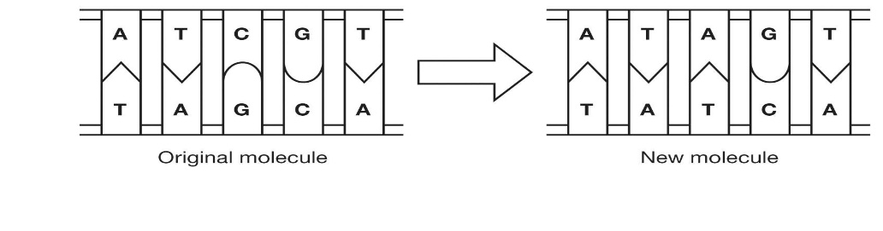
20. The diagram shows one way a mutation can form during DNA replication. What kind of mutation has occurred during the DNA replication shown in the diagram?

A. deletion
B. insertion
C. transcription
D. substitution

DNA is made up of nucleotides that each contain a sugar, a phosphate, and a base. The four possible bases are adenine, cytosine, thymine, and guanine. Remember that adenine and thymine are complementary and form pairs, and cytosine and guanine are complementary and form pairs.
21. Below is half of a section of DNA that has been split apart and is ready to copy itself. Write the appropriate letter in the space provided to build the DNA’s new complementary strand.
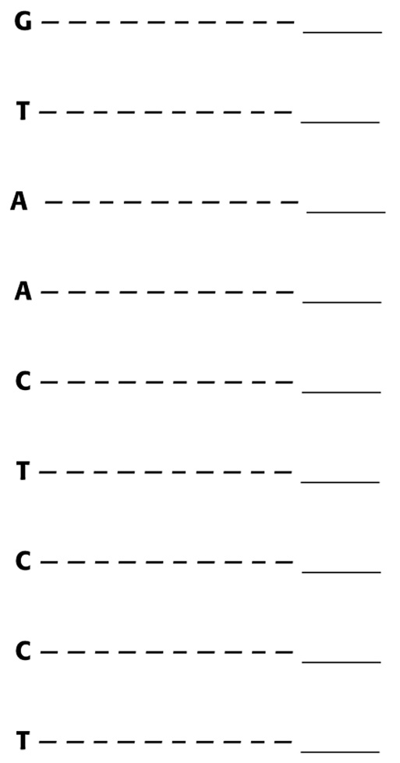

22. Sometimes mistakes happen when the DNA is being copied. These mistakes, or mutations, change the order of the bases in DNA. There are three kinds of mutations that can occur in DNA: deletion, insertion, and substitution.
a. Below are two sequences—an original sequence of bases in DNA and the sequence of bases after a mutation has occurred. On the original base sequence, show where the mutation has occurred by circling the appropriate base pair, and write what type of mutation it is in the space provided.
C G | C G
T A | T A
C G | C G
C G | C G
T A | T A
A T | A T
A T | A T
A T | A T
T A | C G
C G | C G
T A | T A
Base sequence in  original cell DNA | Base sequence in a  cell with mutated DNA

b. Below are two more sequences—an original sequences of bases in DNA and the sequence of bases where a mutation has occurred. On the original base sequence, show where the mutation has occurred by circling the appropriate base pairs and write what type of mutation it is in the space provided.
C G | C G
T A | T A
A T | A T
C G | C G
C G | C G
G C | G C
T A | T A
A T | A T
A T | A T
C G | A T
A T | T A
T A
Base sequence in  original cell DNA | Base sequence in a  cell with mutated DNA
23. Ribosomes “read” a complementary copy of DNA in order to make proteins. Each group of three bases forms the code for an amino acid. When mutations occur in DNA they can change the information that the DNA carries. To understand this process better, look at the sentence below, which uses only three-letter words.
AMY GOT THE RED HOT POT OFF THE LOG
If one letter is deleted from the sequence, it can become:
AMY GTT HER EDH OTP OTO FFT HEL OG
How is this similar to what can happen when a mutation occurs in DNA?

