Name: ___________________________________
Structure of the Earth and Plate Tectonics – Study Guide
1 | The layer of the Earth made up of the rocks basalt and granite | The crust
2 | Where do convection currents flow in Earth’s layers? | The Asthenosphere
3 | What does Earth’s spinning inner core create? | The Earth’s Magnetic Field
4 | What happens to temperature and pressure as depth beneath Earth’s surface increases | It gets Higher
5 | How is heat transferred in the asthenosphere? | Convection Currents
6 | What will happen to convection currents beneath Earth’s surface as the core cools? | They will stop
7 | According to Wegner’s Continental Drift theory the continents… | Once used to be together but started drifting apart
8 | The term used to describe where ocean floor sinks into a deep ocean trench | Subduction
9 | What is Pangaea? | A large landmass that is now our seven continents.
10 | Where the sea-floor spreads apart, where does molten material rise from the mantle? | The mid ocean ridge
11 | What do we call ancient organisms that are preserved in rock? | Fossils
12 | How would you simply describe the mid-ocean ridge? | Longest chain of mountains underwater
13 | List three types of evidence that Wegener used to support his theory of continental drift. | Climate, puzzle like fit , and Landforms
14 | Why was Wegener’s theory rejected by most geologists? | He didn’t have a good explanation
15 | What is the force that causes Earth’s plates to move? | Convection currents
16 | At what type of boundary does a rift valley form? | Divergent
17 | What is the theory that states that Earth’s plates are in constant motion? | Plate tectonics
18 | What is the name of the boundary where two plates collide? | Convergent
19 | What is formed where two continental plates converge? | A Folded Mountain
20 | What is the name of the boundary where two plates slide past each other? | Transform
21 | What forms where two continental plates diverge? | A Rift Valley
22 | What did Wegener call the land mass when all continents were once joined together | Pangaea
23 | What is the name of the theory that states all continents where once joined together but have since drifted to their present positions? | Continental Drift
24 | What do we call the sections of the lithosphere that float on top of the asthenosphere? | Tectonic plates
25 | What is the name of the boundary where oceanic plates sink under a continental plate? | Convergent
26 | What is the name of the process where new oceanic crust is formed? | Sea-floor spreading
27 | What is most likely to occur at a transform boundary? | An Earthquake
28 | Why does oceanic crust subduct under continental crust? | Oceanic crust is more dense
29 | What is most likely to form at and oceanic-continental boundary? | Volcanic mountains
30 | At which type of boundary do Island Arcs form? | Convergent
31 | What is most likely to form at a continental-continental convergent boundary? | A Folded mountain
32 | Earth’s inner core is found inside which of Earth’s layers? | The outer Core
33 | In which of Earth’s layers would the pressure be the greatest? | The inner core
34 | The asthenosphere is part of which of Earth’s layers? | The Mantle
35 | Which of Earth’s layers is the thickest? | The Mantle

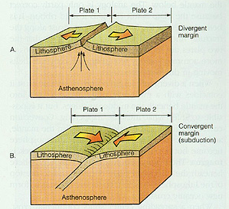
39. What type of plate boundary is occurring in diagram A?
a. convergent b. divergent c. transform
40. What type of plate boundary is occurring in diagram B?
a. convergent b. divergent c. transform
C
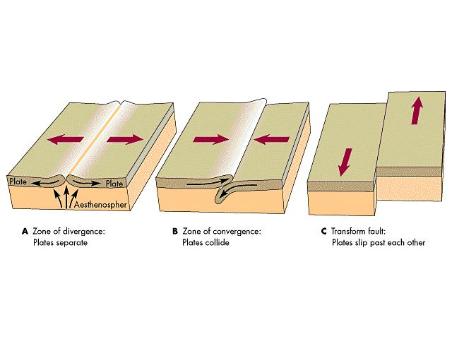
41. What type of plate boundary is occurring in diagram A?
a. convergent b. transform c. divergent
42. What type of plate boundary is occurring in diagram C?
a. convergent b. transform c. divergent
B
A

