Parents – We Need Your Feedback

The state requires that we receive feedback about Lost Mountain by a minimum of 75% of our parents. This is not only a requirement, but a way for you to let us know what we are doing right and what we need to improve.

Please scan the QR Code with a QR code app on a cell phone or device to take the Georgia Department of Education Parent Survey about Lost Mountain Middle School or visit the link below.

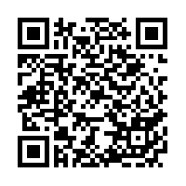

http://apps.gadoe.org/schoolclimate/parents.nsf/Survey.xsp

