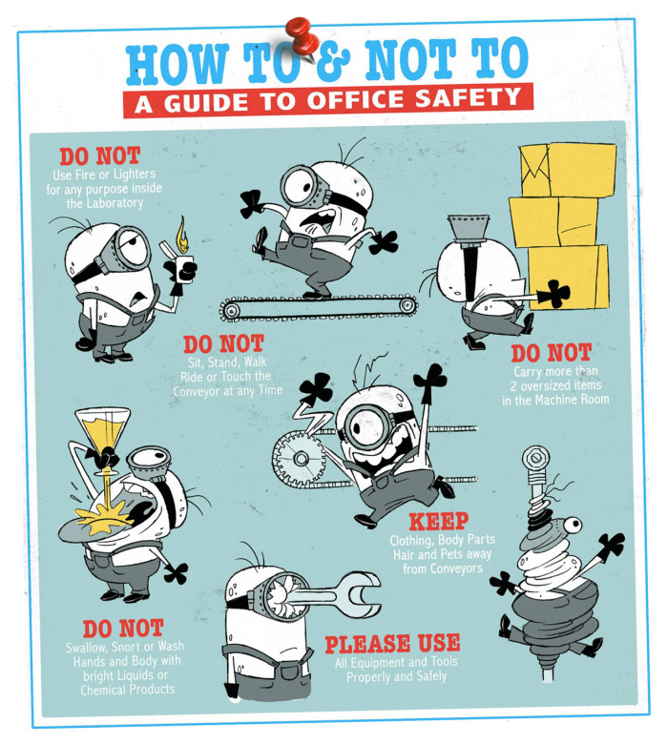
Lab Safety Review
Describe the lab safety needed to help these minions survive their work day! How does the minion safety relate to our classroom? Write 1 paragraph of at least 5 sentences. Use all words below:
- flammable
- lab safety
- tongs
- gloves
- toxic
- goggles
- hazardous
- waft
- horseplay
- electricity
- glassware

__________________________________________________________________________________________
__________________________________________________________________________________________
__________________________________________________________________________________________
__________________________________________________________________________________________
__________________________________________________________________________________________
__________________________________________________________________________________________
__________________________________________________________________________________________
__________________________________________________________________________________________
__________________________________________________________________________________________
__________________________________________________________________________________________
__________________________________________________________________________________________

