Study Guide: Australia

**Geography**

1. What body of water is the Great Barrier Reef located in? ______________________
2. What physical feature in the Northern Territory can appear to glow red at certain times of day? (The Aborigines believe it is very important!!) _________________________________
3. What area is the Great Victoria Desert located in?_________________________
4. What major oceans surround Australia? _________________________
5. Why is it expensive for Australia to import and export goods? (What geographic feature is Australia?)

______________________________________________________________________________________

1. What continent does Australia have a close trade relationship with? ___________________________
2. What language is the most popular in Australia? __________________ Why? ____________________ ____________________________________________________________________________________
3. Due to the fact that the country was colonized by the British, what Monotheistic religion do most Australians belong to? _______________________________________
4. Where do the majority of the people of Australia live? ___________________________
5. What is one of Australia’s most famous tourist attractions? (located in the Coral Sea)

**History**

1. Who are the indigenous people of Australia? _____________________
2. Where did the Aborigine come to Australia from? __________________________________________
3. How is the colonization of Australia similar to the colonization of Latin America? (think of the indigenous people) ___________________________________________________________________
4. Why did so many Aborigines die after the British came? _____________________________________
5. Australia was colonized by the British as a _______________________________________________.
6. What type of people were the early Aborigines? _________________ and gatherers.
7. **(True/False)** There were about 200 different languages spoken by the Aborigines.
8. What is Dreamtime?
9. How is the land important to the Aborigines?
10. How did the British colonization affect the Aborigines? __________________________

**Government Study Guide**

1. What are the three way governments can distribute power? (list three types)

_____________________________ _____________________________ _____________________________

1. What type of government gives the central government all the power to make laws and controls weaker states? ________________________________
2. What government gives individual states power to make their own laws and is loosely aligned to a weak central government? _____________________________
3. What type of government shares the power to make laws between the central government and states? ________________________________
4. What are the three different ways citizens can participate in government? (list three types)

____________________________ _____________________________ _______________________________

1. What is it called when a nation is governed by a single person with unlimited power?

_______________________________________

1. What is it called when a country or nation is controlled by a small group of people that hold the key to power? ____________________________________
2. What is it called when a nation or country receives its power from the people? ________________________
3. Who is the leader of a parliamentary democracy? ____________________________________
4. Do citizens vote directly for the prime minister in a parliamentary democracy? ________________
5. Who is the leader in a presidential democracy? _________________________________
6. Which type of democracy has three branches that are independent of one another and have separate powers?

_____________________________________

1. Do citizens vote directly for the president in a presidential democracy? _________________

**How do governments distribute power?**

|  |  |  |
| --- | --- | --- |
| **Unitary** | **Confederation** | **Federal** |
| **Picture:** | **Picture:** | **Picture:** |
| **Definition**: | **Definition**: | **Definition**: |

**How do citizens participate in the government?**

|  |  |  |
| --- | --- | --- |
| **Autocracy** | **Oligarchy** | **Democracy** |
| **Rule of ONE** | **Rule of FEW** | **Rule of ALL** |
| **Picture:** | **Picture:** | **Picture:** |
| **Definition:** | **Definition:** | **Definition:** |

**Canada Review**

|  |  |
| --- | --- |
| 1. | What are the two official languages of Canada? |
|  | |
| 2. | Where do the least amount of people live in Canada? Why? |
| 3. | What term describes a Canadian whose first language is French? |
| 4. | What major landform is found in both the US and Canada? |
| 5. | Why are the Great Lakes important for shipping & trade in both the U.S. and Canada? |
| 6. | Much of Canada’s mineral wealth is found in a wide area that is rocky, rugged, and not very populated called |
| 7. | Explain how Canada gained independence from the British. |
| 8. | In which province is Canada's capital city? |
| 9. | Who sailed down the St. Lawrence River and heard the Iroquois refer to their villages as "Kanata"? |
| 10. | Which city is the capital of Canada? |
| 11. | Most of Canada's earliest immigrants were from |
| 12. | Quebec citizens who want to officially become an independent country are called |
| 13. | Secede means to |
| 14. | In which provinces do most Canadians live? |
| 15. | Canada Day is celebrated on |
| 16. | Canada's religion is primarily |
|  | |
| 17. | What is the economic system of Canada? |
| 18. | The countries that are members of NAFTA include |
| 19. | Which is most likely to be in a country with a high literacy rate? |
| 20. | What do the economic systems of Canada and the United States have in common? |
| 21. | Most of Canada's population lives within approximately how many miles of the US/Canada border? |
| 22. | Why is the Canadian Shield important to the economy of Canada? |
| 23. | Where in Canada do most people speak French? |
| 24. | Who won the French & Indian War (Seven Years War) over controlling Canada? |

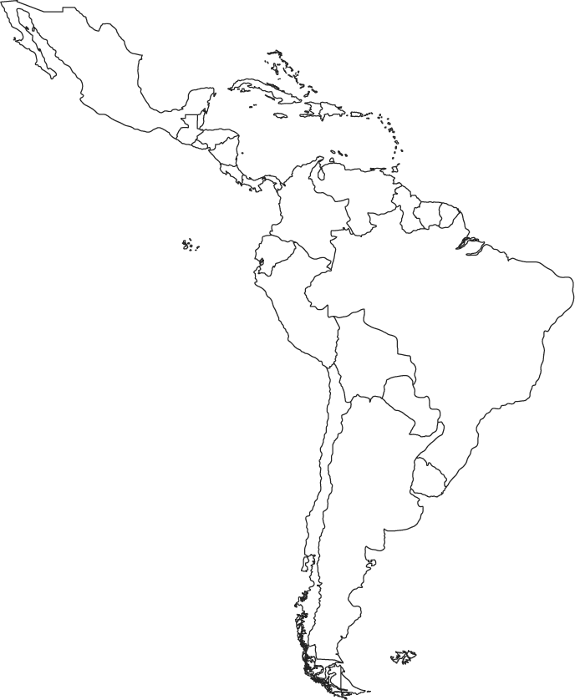**Latin America Study Guide**

**Latin America Geography**

1.What is the largest country in South America? _______________

2. Color in Venezuela green on the map to the right.

3. Put a box around the Panama Canal in purple

4. Draw the Amazon River in Blue

5. What type of pollution does Mexico City have the biggest problem with?

_______________________________________________________

6. What makes Mexico City have such a problem with air pollution?

_____________________________________________________________________________________

7. What environmental issue does Brazil have the biggest problem with? _______________________________

8. Why is the rainforest being cut down in Brazil? (List 4 reasons)

__________________________________________________________________________________________

__________________________________________________________________________________________

__________________________________________________________________________________________

__________________________________________________________________________________________

9. What environmental issue does Venezuela have the biggest problem with? ___________________________

10. What are some ways oil leaks into water and onto land? __________________________________________

__________________________________________________________________________________________

__________________________________________________________________________________________

11. Which two European languages are mostly spoken in Latin America? _______________________________

12. What is the blending of European and Africans?______________ Europeans and Indigenous?__________

13. Which language group does Spanish and Portuguese come from?

**History of Latin America**

1. Explain the roles of Montezuma II, Hernan Cortez, Francisco Pizzaro, and Atahualpa in Latin American history.

Montezuma II-

Hernan Cortez-

Francisco Pizzaro

Atahualpa-

1. Why were Cortez and Pizzaro able to conquer the Incas and Aztecs fairly easily?

________________________________________________________________

1. Where was the Aztec empire in Latin America? ________________________________

Inca Empire? _____________________________

1. Spain colonized many countries in Latin America. How is their influence still seen in these countries today? _______________________________________________________________

____________________________________________________________________

1. What is the name of the Spanish conquerors that took Latin America from the natives?
2. What did the Spaniards introduce to the Americas that changed how the Native Americans lived and how they conducted war?
3. What three areas were most impacted from the Colombian Exchange?

_____________________________, ________________________________, _____________________________

1. Why did the African Slave trade grow in Latin America?
2. **For each of the people listed below do the following**: Tell me which countries independence they were fighting for?, Were they successful in getting independence during their lifetime?, why/how did they die?

**Toussaint L’Ouverture:**

* Country:
* Independence:
* Death:

**Simon Bolivar:**

* Countries:
* Independence:
* Death:

**Miguel Hildalgo**

* Country:
* Independence:
* Death:

1. **Cuban Revolution**: Who took over Cuba in 1959? ____________________

What was the United States relationship with Cuba after the Revolution? ___________________________

What type of Government did Castro put in after he took over?

1. Who were the Zapatista’s named after?_________________________ What changes did the Zapatistas want? _____________________________________________________________

How did the Zapatistas feel about NAFTA?

Did the Zapatistas get what they wanted? What did they get?

Economics Study Guide

1. What are the three basic economic questions all economic systems have to answer?

____________________________________________  
____________________________________________

____________________________________________

2. What are the three types of economic systems?

____________________________________________

____________________________________________

____________________________________________

3. What does it mean to have a mixed economy? __________________________________________________

4. Fill in the chart below. Tell how each economic system answers the economic questions.

|  |  |  |  |
| --- | --- | --- | --- |
|  | **Traditional** | **Command** | **Market** |
| What to produce? |  |  |  |
| How to produce? |  |  |  |
| For whom to produce? |  |  |  |

5. What are the four factors of production?

______________________________________________________________________________________

______________________________________________________________________________________

6. What are capital goods? ___________________________________________________________________________

7. Why would business owners want to invest in capital goods? _____________________________________________________________________________________

8. What is labor? ___________________________________________________________________________

9. What is human capital? ____________________________________________________________________________

10. How do you invest in human capital? _______________________________________________________________

11. When you invest in human capital you make more ______________________________.

12. What are natural resources? _______________________________________________________________________

13. What are entrepreneurs in you own words? ___________________________________________________________

14. What is a trade barrier? ______________________________________________________________________

15. List 3 types of trade barriers.

__________________________________________________________________________________________________

16. What is a tariff and how does it restrict trade? _______________________________________________________ ________________________________________________________________________________________________

17. What is an embargo and how does it restrict trade? ____________________________________________________ _________________________________________________________________________________________________

18. What is a quota and how does it restrict trade? ______________________________________________________ ________________________________________________________________________________________________

19. How do trade barriers affect imports? _____________________________________________________________

20. Draw the Economic continuum.

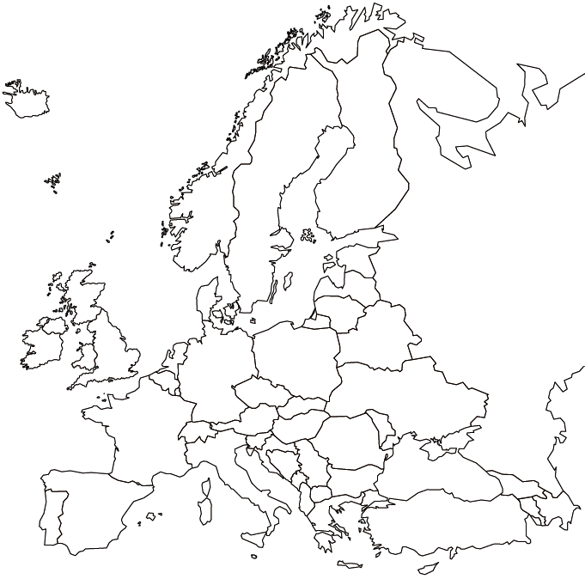Study Guide: Europe

Label the following places on the Europe map:

**Physical Features**: Mediterranean Sea, Danube River, Rhine River, English Channel, Atlantic Ocean, Arctic Ocean, European Plain, the Alps, the Pyrenees, Ural Mountains, Iberian Peninsula, Scandinavian Peninsula

**Nations:** United Kingdom, Russia, Germany, France, Spain, Italy, Belgium, Ukraine, Portugal

Geography

1. What river runs through southern Europe?_____________Germany?_______________________
2. What mountains divide Spain from France?________________ Italy from the rest of Europe?________ Europe and Asia?__________________
3. What countries make up the Iberian Peninsula? ________________________ The Scandinavian Peninsula?__________________
4. Explain how the location of the U.K. is different from Russia’s location. _________________________________

__________________________________________________________________________________________

1. Explain how the location of Germany influences the country’s trading. ___________________________________________________________________________________
2. What two physical features influence trade in Italy? ________________, _______________________
3. What languages do they speak in the following countries: Germany_________, France________, U.K.________, Russia___________, Italy__________.
4. What is monotheism? _________________________________________________________________
5. What is a literacy rate and is it high or low in most European countries? ________________________________________________________________, _____________
6. Define standard of living and how does it relate to the term literacy rate? _____________________

________________________________________________________________________________

Fill in the chart about European religions below:

|  |  |  |  |
| --- | --- | --- | --- |
| Religion | Christianity | Islam | Judaism |
| Holy Text |  |  |  |
| Founder |  |  |  |
| House of Worship |  |  |  |
| Core Belief |  |  |  |

**Government**



|  |  |  |  |
| --- | --- | --- | --- |
| Governments | U.K. | Germany | Russia |
| Distribution of Power |  |  |  |
| Citizen Participation |  |  |  |
| Type of Democracy |  |  |  |

**History**

1. What the four main European countries who explored beginning in the 1400s?__________, __________

__________________, ________________

1. What are the four main reasons for exploration and can I explain them? ________________________

_______________________, _______________________, _________________________________

1. What continent did Spain mostly colonize? __________________
2. What does the word imperialism means? _________________________________________________
3. Why did Europeans want to find a sea route to Asia? ________________________________________
4. Who was Prince Henry the Navigator? ____________________________________________________
5. Name a cause of European colonization? _________________________________________________
6. Empire building contributed to the start of what war? ___________________________
7. Why did France want the Treaty to be so harsh for Germany after World War I? ___________________________________________________________________________________
8. List the effects of WWI. ___________________, ____________________, __________________
9. What was the worst part of the Versailles Treaty for Germany's Economy? _______________________________
10. What role did Vladimir Lenin play in the Russian Revolution? ________________________________________
11. What was a cause of the Russian Revolution? ______________________________________________________
12. What type of government did Czar Nicholas have in Russia? __________________________________________
13. Who was the leader of the Nazi party during World War II? ___________________________
14. What type of government did Hitler run? _____________________________
15. The Holocaust occurred during which war? _______________________________
16. Which two superpowers engaged each other during the Cold War? __________________, __________________
17. What was the purpose of the Berlin Wall? ________________________________________________________
18. What European country was once divided and then fell after the fall of the Soviet Union? _________________________________