NAME: ___________________________ Due Date: _____________
STUDY GUIDE for Government/Economics of Southwest Asia
Define the following terms:
- Autocracy: government in which one person has uncontrolled or unlimited authority over others
- Oligarchy: government by a small group of people
- Democracy: the supreme power is vested in the people and exercised by them directly or indirectly
- Theocracy: a government ruled by religious leaders who claim God’s authority
- Presidential democracy: a political system in which voters separately choose a leader to serve in the government as head of the executive branch
- Parliamentary democracy: a form of government in which voters elect representatives to a lawmaking body, which then chooses the leader; head of government is a part of the legislative branch
- Command economy: government decides what is produced, who receives goods and services, and how things are produced
Examples: North Korea and Cuba are close to pure command.
- Market economy: consumers and producers determine what’s produced, who receives goods/services, and how things are produced (supply and demand). Also called “capitalism” or “free market” – encourages entrepreneurs (creators of new businesses)
- Mixed economy: when a country combines elements of market and command systems (and sometimes traditional elements as well) *Most societies fall under this category, including ours!)
Part 2
- Israel:
  - Type of government: Parliamentary Democracy
  - Title and name of current leader: Prime Minister Benjamin Netanyahu
- Turkey:
  - Type of government: Parliamentary Democracy
  - Title and name of current leader: President Recep Erdogan
- Saudi Arabia
  - Type of government: Islamic Autocratic/Absolute Monarchy
  - Title and name of current leader: King Salman
Part 3
- What does OPEC stand for and what does it do?
  - Organization of the Petroleum Exporting Countries – decides how much oil to produce and the price

Part 4
- Turkey’s primary industries: textiles, steel, and cars
- Israel’s primary industries: high-tech manufacturing (aviation, cars), financial services, timber, agriculture
- Saudi Arabia’s primary industries: world’s second leading producer of oil
Draw and place Turkey, Israel, and Saudi Arabia on the economic continuum below:
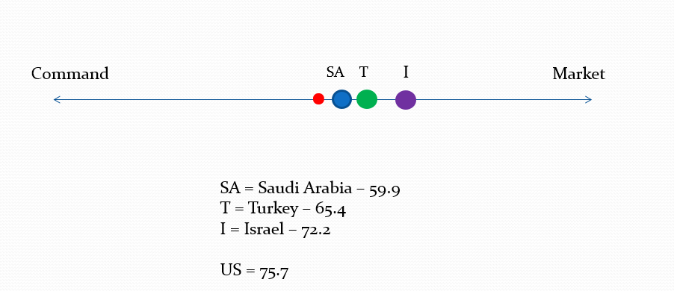

Part 5: Understand the meaning of specialization.
Definition of Specialization: Specialization is a method of production where a business, area or economy focuses on the production of a limited scope of products or services to gain greater degrees of productive efficiency within an overall system. Many countries, for example, specialize in producing the goods and services that are native to their part of the world, and they trade for other goods and services. This specialization is therefore the basis of global trade, as few countries have enough production capacity to be completely self-sustaining.
Read more: Specialization http://www.investopedia.com/terms/s/specialization.asp#ixzz4vm2BAVLi
What is its purpose? To gain greater degrees of production efficiency (If a country can produce something cheaper than something else, they can use all of their resources to produce that thing, and then, they can trade their special thing with other countries for what is more expensive for them to have.) It would be more expensive and would waste resources for countries to try to produce everything that they need.

Give an example of specialization from your notes.
Different countries have different resources. Saudi Arabia has large oil reserves that are relatively easy to extract, but is extremely arid which means it is relatively hard for them to grow food. The United States has large fertile plains which are great for growing food, but most of its oil reserves are relatively expensive to extract. While Saudi Arabia could produce its own food and the United State could produce its own oil, both countries would have to shift resources away from producing goods and services that they are better off making and both countries would have less. Through specialization and trade, the United States and Saudi Arabia can both focus at what they are good at doing, trade, and have more total goods and services.

VI. Trade Barriers
Voluntary trade ____benefits_________________ both countries.

Describe the three trade barriers.
- Quota – a restriction or limit on the amount of a good that can be imported (government imposed)
- Tariff – a tax on imports or exports
- Embargo: a government ban on certain imports for political or economic reasons

Why are trade barriers used? Why do they hurt countries?
Sometimes countries create trade barriers to pursue the country’s interests. This could be to punish another country or to protect an industry within the country creating the trade barrier. These trade barriers always hurt both parties that would otherwise be trading.

