Name_______________________________________________________Date_______________Period_______
Levels of Environmental Organization Task
Part A: Poster
Directions:
Create a poster to illustrate the levels of environmental organization. The levels of organization must be incorporated into an object of your choice.
- Draw an object of your choice which fills the entire page you have been given.
- Incorporate the levels of organization within the object you have drawn.
- Label and illustrate each of the 5 levels of organization in the correct order.
  - organisms, population, community, ecosystem, and biosphere
- Create a title and write it across the top of the poster.
- Write your name, date, and class period on the back of the poster.
- Make sure your drawing is neat, colorful, and fills the entire page.

Example:
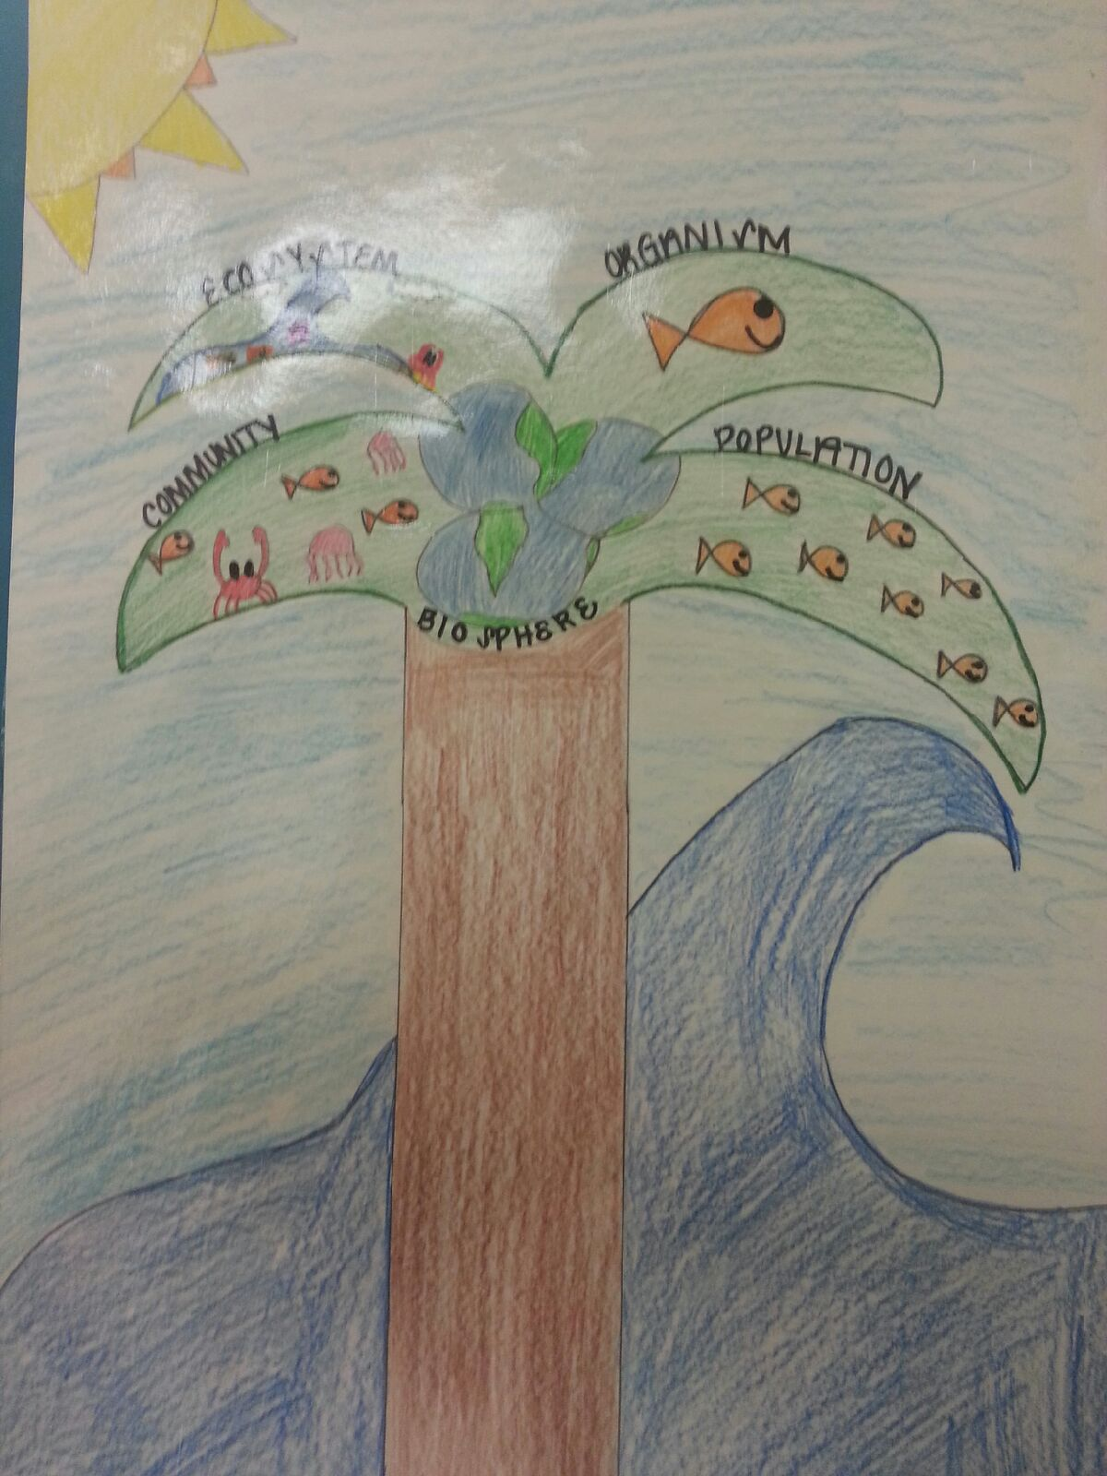
This example would be perfect if it had a title across the top.

Part B: Reflection
Directions:
On the back of your poster, write one paragraph (5 to 7 sentences) explaining how your entire object and the parts of your object correspond with the different levels of environmental organization. Be sure to give real world examples in your explanation.
Rubric:
Category | Points Possible | Points Earned
Levels of organization incorporated within the object | 15
Labels and illustrations for each of the 5 levels of organization  - Organisms  - Population  - Community  - Ecosystem  - Biosphere  Levels are in correct order and illustration is accurate for each level. | 45
Title | 5
Neat, colorful, & fills the page | 10
Reflection | 25
Total | 100

