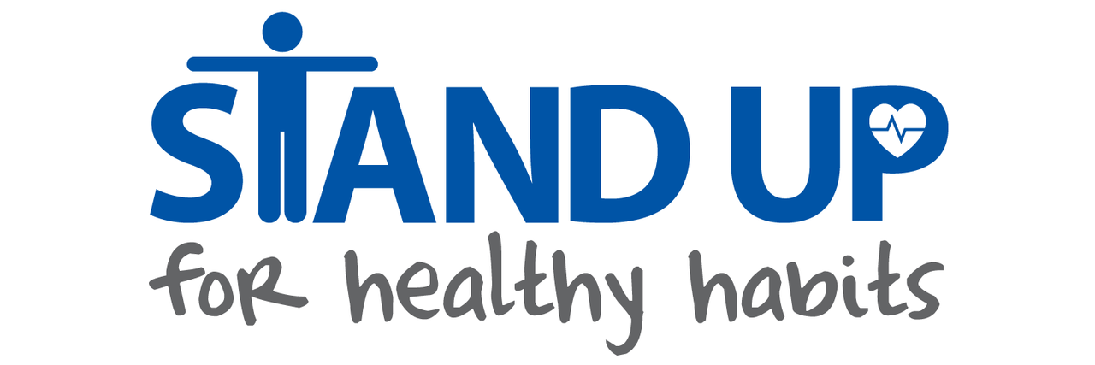
Healthy Habits is a student created group at Lost Mountain Middle School working to get flexible seats in every classroom in our building.
Currently, our flexible seats include wobble stools, stand up desks, desk cycles, stability balls, and bouncy bands, which are bands you can attach to the bottom of your seat to bounce wiggle. With all of these flexible seats, students can achieve stronger flexibility, burn calories, and exercise. Studies show that students just sit at normal desks 7 hours a day each weekday and may not have the time to achieve flexibility, burn calories, or exercise. Our flexible seating can help every student in the Lost Mountain community!!
But we need your help! You can help in any of the following ways:
- Help us fundraise! You can donate money directly to Stand Up for Heathy Habits; please make checks payable to Lost Mountain Middle School (memo line: Stand Up for Healthy Habits).
- Come to Moe’s Night on Thursday, November 17th, anytime between 5 pm and 9 pm (Dallas Hwy location).
- Email our club sponsor with any questions:
  - Mrs. Jaime Williams – Jaime.williams@cobbk12.org
Sincerely,
Lost Mountain’s HEALTHY HABITS

