Human Body Systems Interactions – Study Guide
Levels of Organization Fill-in-the-Blank
- Cells work together to form __________. __________ work together to form organs. Organs work together to form __________ __________. __________ __________ make up organisms.
- Word = __________
Sentence = __________
Word Bank for Questions #1 & #2:
cell organ tissue organism organ system
Paragraph = __________
Chapter = __________ __________
Book = __________
Human Body System Matching
- _____Nervous System | - The major organs of this system are the lungs. This system allows the body to breathe.
- _____Integumentary System | - The major organs of this systems are glands that produce chemicals to help control body functions such as growth and development.
- _____Digestive System | - White blood cells in this system fight pathogens (germs).
- _____Skeletal System | - The major organs of this system include the tonsils, the spleen, and other lymph nodes that help remove dead pathogens (germs) and other wastes from the body by contracting of skeletal muscles.
- _____Excretory System | - The major organ of this system is the skin. This system covers and protects the body.
- _____Lymphatic System | - The 3 types of tissue in this system include smooth, striated, and cardiac. This system provide shape, support, and movement for the body.
- _____Respiratory System | - The major organs of this system include the brain and spinal cord. This system controls the body.
- _____Endocrine System | - The major organs of this system include the kidneys and the bladder. The kidneys filter the blood and produce urine that is stored in the bladder until the body is ready to release the waste.
- _____Muscular System | - The major organs of this system are the heart and the blood vessels. This system provides transportation for nutrients, oxygen, and other substances throughout the body.
- _____Cardiovascular System | - The human body has 206 bones that help protect the internal organs and a variety of joints that allow movement. This system also produces red blood cells in the marrow of the bones.
- _____Urinary System | - This system has many organs including the stomach and the intestines. This system is responsible for breaking down food for the body.
- _____Immune System | - This system consists of 4 other systems that help the body removes wastes. These systems include the integumentary (sweating), respiratory (exhaling carbon dioxide), urinary (releasing urine), and digestive systems (releasing feces).

Systems Interactions
Action | Which body systems are in use  during this action? | How do you know these systems  are part of this action?
Brushing your teeth | skeletal, muscular, nervous, respiration, cardiovascular | respiration and cardiovascular give you energy to move your muscles; the muscles are moving the bones to lift and maneuver the toothbrush to clean the teeth which are also bones; the nervous system is directing the action using information from the senses (eyes, touch, taste)
Scoring a touchdown

Texting

Eating breakfast

How does the skeletal system interact with the…
- …muscular system? ___________________________________________________________________
__________________________________________________________________________________________
- …respiratory system? _________________________________________________________________
__________________________________________________________________________________________
- …cardiovascular system? ______________________________________________________________
__________________________________________________________________________________________
- …nervous system? ____________________________________________________________________
__________________________________________________________________________________________
- …digestive system? ___________________________________________________________________
__________________________________________________________________________________________
- …immune system? ___________________________________________________________________
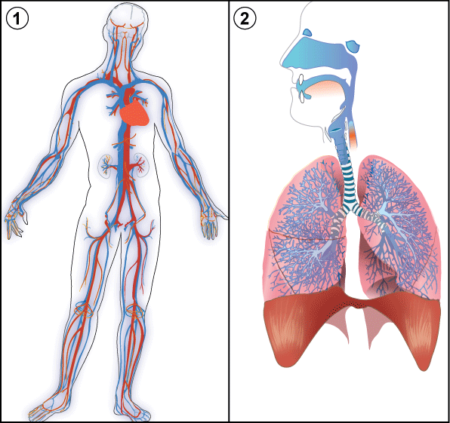
__________________________________________________________________________________________
- What 2 systems are pictured in the diagram and
how do they work together?
________________________________________________________
________________________________________________________
________________________________________________________
________________________________________________________

