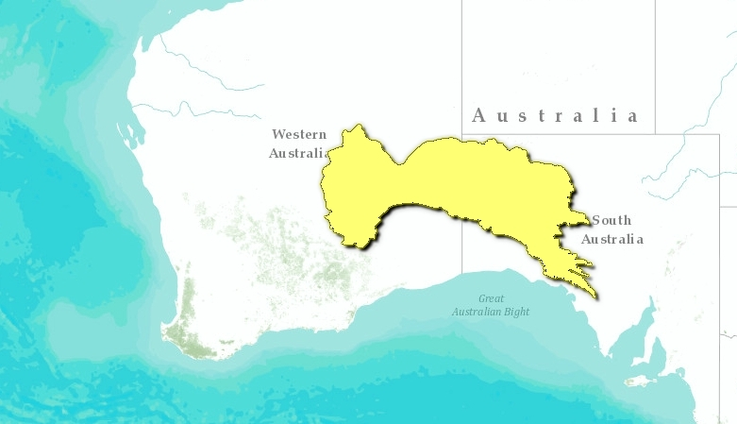
Great Victoria Desert
A vast, sparsely populated region covered by dunefields and gibber plains, the Great Victoria Desert receives little rain and experiences extreme temperatures. A highly desert-adapted fauna lives here and the area is known for its lizard diversity. Climate and isolation render pastoralism and agriculture inviable, so the region has suffered few direct effects of European settlement. The presence of weapons testing range and nuclear weapons test sites has further isolated the region and means that this is one of the least populated areas of Australia.

Location and General Description
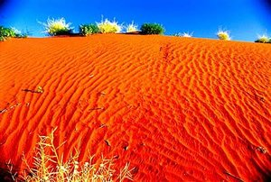
The vast Great Victoria Desert extends from the Eastern Goldfields area in Western Australia across the southern parts of central Australia to the Stuart and Gawler Ranges in South Australia. The climate is arid, with mean annual rainfall ranging from below 150 millimeters (mm) to over 250 mm. Rainfall is a seasonal, but shows great variability between years. Summers are very hot, with mean maxima during summer between 32 °C and 35 °C. Diurnal ranges are also large, and overnight minima commonly fall below 0 °C during winter. Much of the region is occupied by sand dunes, with areas of calcrete and silcrete. Dunes cover low-elevation areas, interspersed among low ranges, dissected tablelands, and plains.
Much of the Great Victoria Desert is vegetated by open woodlands, typically eucalypts with a hummock grass understory with other grasses, or belah with shrubs. The ‘Giles Corridor’ is a narrow strip of Acacia vegetation and the only continuous shrubland to completely traverse the Great Victoria Desert. This corridor links the Pilbara region in Western Australia to the Central Ranges by going though the Lake Carnegie region in the Great Victoria Desert and the southern part of the Gibson Desert. Gibber plains also occur in this ecoregion, consisting of areas in which the soil is covered by a closely-spaced layer of pebbles, and glazed with a thin wind-polished layer of iron oxides. Gibber plains are normally almost devoid ofvegetation, but following rains may be densely covered with ephemeral species, especially Fabaceae, Compositae, and Amaranthaceae.

Biodiversity Features
One of the strategies that allows animals to persist in such extreme environments is to be highly mobile and follow favorable conditions across great distances. Consequently endemism is low, especially among birds and larger mammals. Nevertheless, the endangered chestnut-breasted whiteface has a relatively restricted range, spanning the eastern parts of this region and the western parts of the adjoining Tirari-Sturt stony desert region. The vulnerable malleefowl occurs within the Unnamed Conservation, and, although not reported from the region in recent decades, it is conceivable that the enigmatic and critically endangered night parrot is still present.
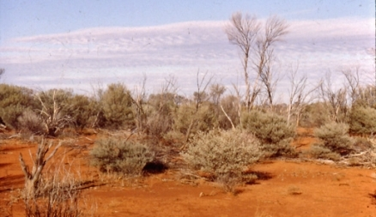
The Great Victoria Desert also has an exceptionally high diversity of reptiles, including the vulnerable great desert skink which had been considered extinct in South Australia until its rediscovery by Aboriginal landholders in 1998. More than 100 species of reptile have been recorded. Extensive lizard radiations and speciation occurred all over the arid interior of Australia, largely in response to climatic changesin the late Pleistocene and the associated shifting and isolation of vegetation pockets. An example of this isolation can be seen in the Great Victoria Desert, where a population of Ctentus brooksi is isolated from populations in the Simpson Desert by a narrow strip of scrub vegetation in south-central Northern Territory. Although the barrier is only several thousand years old, distinct subspecies have evolved, with C. b. brooksi found in the Great Victoria Desert. Diversification in habitat results in high lizard density: in a portion of the Great Victoria Desert in Western Australia up to nine different species of geckos may overlap, with species utilizing a wide variety of food and habitats (sand seas, sandridges, rocky breakaways, and salt lakes).
Several threatened mammals, the endangered sandhill dunnart, the endangered marsupial mole, and the vulnerable mulgara still occur within the region. Australia has experienced nearly half of the world’s mammal extinctions within the past 200 years, with most of the extinctions concentrated in drier interior regions of the continent.

Current Status
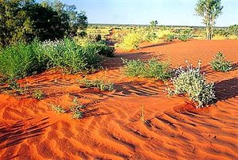
As a consequence of the climate and the geographical isolation of the region, pastoralism and agriculture are not considered viable. Consequently, there has been little land clearance or grazing by domestic stock. A weapons testing range and nuclear weapons test sites are located in this region. Some areas have been disturbed by mineral exploration and mining, but these impacts are low when considered at the regional scale. Furthermore, extensive tracts of land are protected from exploitation. The Unnamed Conservation Park (21,289 square kilometers) on the South Australian – Western Territory border is the largest of South Australia’s conservation areas. A further 103,000 square kilometers is effectively conserved in the adjacent Pitjantjatjara Lands, which were ceded to traditional landowners by the South Australian Parliament in 1981. In Western Australia, some 20 percent (5000 square kilometers) of the Great Victoria Desert Nature Reserve falls within the region.

