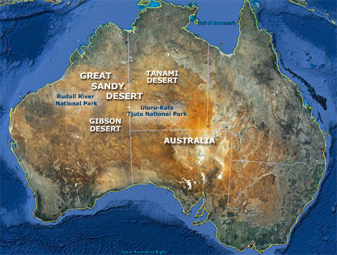
Australia's Great Sandy Desert

The Great Sandy Desert is located across northwest and central Australia. It contains two of the country's most famous parks, the Rudall River National Park and Uluru-Kata Tjuta National Park where the famous Ayers Rock is located.
Spanning roughly 150,000 square miles, western Australia's Great Sandy Desert is the second largest of the continent's 10 desert regions--all, collectively, located across the central and northwestern part of the country. The largest is the 164,000-square-mile Great Victoria Desert, located in the southwestern part. The smallest is the 480-square-mile Pedirka Desert, located in the south-central part.

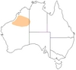
Location
The Great Sandy Desert extends from northwest Australia's Indian Ocean coastline inland, southeastward for more than 800 miles. It lies between the 71,000-square mile Tanami Desert, to the northeast, and the 60,000-square mile Gibson Desert, to the south. Those three deserts converge near the geographic center of the continent, at the famed bare red sandstone dome Ayers Rock, or, in the aboriginal language, "Uluru."

Climate
The Great Sandy Desert falls into the classification of a "hot desert." This means that in a typical year, it receives little rain, and it experiences high temperatures, low humidity and high evaporation rates.
- The desert's precipitation -- driven primarily by summer monsoonal patterns -- varies widely from year to year, equaling, on average, no more than a few inches annually, said the Australian Natural Resources Atlas.
- Daytime temperatures average about 105 degrees Fahrenheit during its long summers and, typically, 68 degrees during its short winters (with occasional nighttime frosts in higher elevations).
- Usually, its humidity ranges from 10 to 20 percent.
- Its evaporation rate equals 10 to 12 feet per year, approximately 15 to 20 times the average precipitation per year.

Landscape
Gently undulating and sparsely vegetated, the Great Sandy is largely characterized by short ephemeral drainages, several lakes and wetlands, red sand dunefields, and remnant rocky outcrops, according to the Australian Natural Resources Atlas. Typical of the world's deserts, most of the Big Sandy's creeks and rivers flow only after heavy rainfalls, sometimes leaving short-lived playa lakes in their wake. Many of its longer-lived lakes and wetlands, arising primarily from springs and seepages, owe their origins to ancient and now inactive river systems, one that flowed across the northern part of the desert and another that flowed across the southern part. The Great Sandy's single modern river, the Rudall, rising in highlands and feeding wetlands along its course, flows across the desert and empties into the large, salty Eva Broadhurst Lake. It lies in the heart of the Karlamilyi National Park. The Great Sandy's dunefields comprise both variable and remarkably consistent forms. Its rocky outcrops include sandstone, siltstone and mudstone ridges and ranges in the southeastern part of the desert.
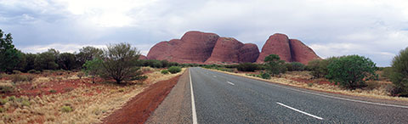
The Great Sandy Desert's most striking features include:
- Ergs -- or seas of sand -- that comprise linear, parallel dunes sculpted by winds blowing the same direction over a prolonged period. The dunes, covering much of the Big Sandy, extend for 25 to 30 miles or more in length, rise to 50 feet in elevation and trend west-northwest in orientation. From the air, the Great Sandy's ergs resemble immense furrowed fields.
- Kata Tjuta ("Many Heads" in the aboriginal language) that consist of some three dozen bald red sedimentary rock domes that tower above the desert floor in the southeastern part of the Great Sandy. Home to numerous mythical figures, the Kata Tjuta domes have been sacred to various Aboriginal Australian tribes for perhaps 22,000 years.
- Ayers Rock, or Uluru, that ranks as the second largest monolith, or "island mountain," in the world, after Mount Augustus, also in Australia. Also sacred to the Aboriginals, Uluru, standing 1148 feet above the surrounding desert, stands as Australia's most iconic natural formation. It and Kata Tjuta serve as the central attractions for the country's Uluru-Kata Tjuta National Park.
- Wolfe Creek Crater that marks the site where a 55,000-ton asteroid, traveling 10 miles per second, struck some 300,000 years ago, according to the Outback Australia Travel Guide. The crater measures a half mile in diameter. Its rim rises some 80 feet above the surrounding desert. Its floor lies some 150 to 200 meters below the rim. Located in the transitional area between the Great Sandy and Tanami Deserts, in the north-central part of Australia, the crater is the principal feature of the Wolfe Creek National Park. According to Aboriginal beliefs, the crater marks the site where a rainbow serpent emerged from the ground.
Environment
The Great Sandy Desert is very flat, which is all the more noticeable next to the rocky ranges and hills in the Kimberley or Pilbara.
It is also, as the name says, sandy. In the Great Sandy Desert you can actually find what many people expect from a desert: sand dunes. Tall red sand dunes in parallel rows cover miles and miles of this desert.
But you also find sandstone country, low hills, and even chains of salt lakes. The prevailing vegetation form is tree steppe, and shrub steppe in the south, meaning open grasslands with occasional tress or shrubs: bloodwood, acacias, grevilleas, and further south desert oaks.
The Great Sandy Desert has the same problem as the other Australian deserts: native animals are threatened by introduced feral species. Cat and fox populations are high, camels are plentiful, and rabbits are present in the southern parts. Cats and foxes are a direct threat to the native species they prey on, whereas camels and rabbits are detrimental to the native vegetation.
Another problem I already mentioned on other desert pages is theincreasing tourist pressure. In the Great Sandy Desert the area most under pressure is obviously Kata Tjuta - Uluru (Ayers Rock) in the south-east corner.

