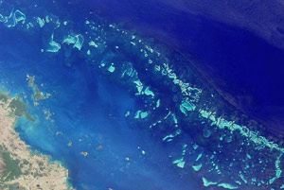
Welcome to the Great Barrier Reef
One of Australia's most remarkable natural gifts, the Great Barrier Reef is blessed with the breathtaking beauty of the world's largest coral reef. The reef contains an abundance of marine life and comprises of over 3000 individual reef systems and coral cays and literally hundreds of picturesque tropical islands with some of the worlds most beautiful sun-soaked, golden beaches.
Because of its natural beauty, the Great Barrier Reef has become one of the worlds most sought after tourist destinations. A visitor to the Great Barrier Reef can enjoy many experiences including snorkeling, scuba diving, aircraft or helicopter tours, bare boats (self-sail), glass-bottomed boat viewing, semi-submersibles and educational trips, cruise ship tours, whale watching and swimming with dolphins.

How was the Great Barrier Reef formed?
The Great Barrier Reef is an extremely ancient, enormous host of living things, composed of living coral growing on dead coral dating back perhaps as much as twenty million years. Many generations of dead coral have built themselves into great walls of stone covered in a diverse range of living organisms such as coral, algae, anemones, sponges, fish, worms, starfish, turtles, mollusks, snakes, crustaceans, and an extraordinary array of thousands of species of plants and animals.
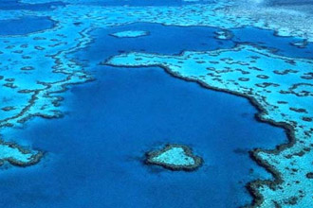
Although there is no direct physical evidence, first human contact with the reef must've occurred for some time. We know that Aboriginal people occupied great parts of the Australian continent for around 40,000 years. Aboriginal and Torres Strait Islander peoples have fished and hunted its waters and navigated between the islands of the reef region.
For large parts of that time, during periods of glacial activity, the area of the Great Barrier Reef was dry with large flat coastal plains. This area is at a depth of less than one hundred meters below sea level today.

About the Great Barrier Reef
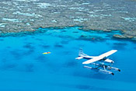
The Great Barrier Reef is one of the seven wonders of the natural world, and pulling away from it, and viewing it from a greater distance, you can understand why. It is larger than the Great Wall of China and the only living thing on earth visible from space.
The Great Barrier Reef is a breeding area for humpback whales, migrating from the Antarctic and is also the habitat of a few endangered species including the Dugong (Sea Cow) and large Green Sea Turtle.

In 2006 there were approximately 820 operators and 1500 vessels and aircraft permitted to operate in the Great Barrier Reef Marine Park providing ease of access for all to experience the Great Barrier Reef and learn first hand about its natural delights and World Heritage values.

Where Is The Great Barrier Reef?
The marine park stretches over 3000km (1800 miles) almost parallel to the Queensland coast, from near the coastal town of Bundaberg, up past the tip of Cape York. The reef, between 15 kilometres and 150 kilometres off shore and around 65 Km wide in some parts, is a gathering of brilliant, vivid coral providing divers with the most spectacular underwater experience imaginable.
A closer encounter with the Great Barrier Reef's impressive coral gardens reveals many astounding underwater attractions including the world's largest collection of corals (in fact, more than 400 different kinds of coral), coral sponges, mollusks, rays, dolphins, over 1500 species of tropical fish, more than 200 types of birds, around 20 types of reptiles including sea turtles and giant clams over 120 years old.

