Propaganda Poster Extra Credit Opportunity

Your assignment is to create a unique propaganda poster for distribution during the Russian Revolution or The Rise of Nazism. Your poster can be geared towards any audience (men, women, children), and can be in reference to any aspect of the Russian Revolution or the Rise of Nazism (support for the tsars, anti-tsars, pro WWI, anti-WWI, support for the workers, nationalism, pro-Nazi, anti-Communism, blaming depression on signing the Treaty of Versailles, etc).

The intended audience must be clear just by looking at the poster.

The message must make the viewer feel something (angry, sad, patriotic, vindictive, scared, proud, or changes their opinion on their role in the Russian Revolution or the Rise of Nazism, etc).

You can type or draw the poster on an 8 ½ x 11 piece of paper.

Directions: Follow the steps below.

- Choose either the Russian Revolution or the Rise of Nazism to create your propaganda poster.
- Read the rubric so that you know how you will be graded.
- The goal of a propaganda poster from the government is to make the public believe something or do something that the government wants them to do. It can show an enemy in a harsh manner or tug at your heart strings to make the public sympathetic to a cause.
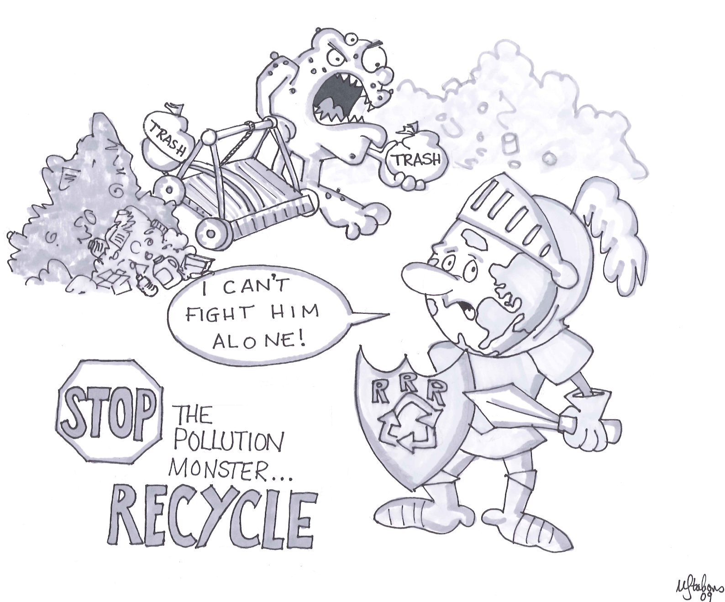
- For example, if the task was to make a propaganda poster that was pro-environment, the poster might look like the following because it encourages you to recycle.

- Create your Propaganda Poster!

RUBRIC | 8 | 6 | 4 | 2 | 0
Content | Product fully relates to the content and shows understanding of the content | Product relates to most of the content and shows understanding of that content | Product relates to part of the content and shows understanding of that content | Product relates to part of the content but doesn’t show understanding of that content | Product doesn’t relate to the content
 | 4 | 3 | 2 | 1 | 0
Drawing | Drawing is detailed attractive and relates to the content of the page | Drawing is somewhat detailed, attractive and relates to the content of the page | Drawing is not detailed or attractive or does not relate to the content of the page | Drawing is messy or without detail and does not relate to the content of the page | There is not enough of a drawing to grade
Use of Propaganda | Use of persuasion is evident and shows the information in a positive or negative light | Attempts to use persuasion and the information is shown to be positive or negative | Attempted the use of persuasion but the information is seen in both a positive and negative light | Attempted to use persuasion but it was done incorrectly | No persuasion or viewpoint is evident
Spelling and Grammar | Perfect spelling and grammar | A couple of spelling or grammar mistakes | Several spelling or grammar mistakes | Due to the amount of spelling or grammar mistakes, the product is illegible | There is no writing on the poster
Grade | /20

Due: Thursday, December 10

