Name______________________________________ Period _________________________ Date______________

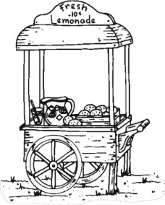
Eagle Entrepreneurial Extravaganza
Social Studies Checklist

Flyer Completed

Name of YOUR Company __________
Logo __________
Brief description of your business __________
Product & Price Info __________
Slogan __________
Business Cards

YOUR Name __________
Name of YOUR Company __________
Logo __________
Slogan __________
Company Address __________
Company Phone Number __________
Email & Website __________
Social Media Info (optional) __________

Logo

Creative __________
Relevant to YOUR Business __________

