Name______________________________________ Period _________________________ Date______________
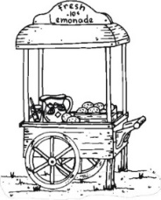
Eagle Entrepreneurial Extravaganza
TRIFOLD BOARD CHECKLIST

LEFT SIDE / American Business Checklist

Name of American Business & Ten (10) Detailed Facts __________/10
Pictures or Logo __________/10

MIDDLE / Your Business

Name of YOUR Company & Slogan __________/10
Flyer with Logo __________/10
Business Card with Logo __________/10
Infographic __________/10
Pictures of Product __________/10
Pricing Information __________/10

RIGHT SIDE / Your Business Plan

Business Plan Attached __________/10
ENTIRE POSTER
Creative / Neat __________/10

TOTAL __________/100

