The Congo Basin makes up one of the most important wilderness areas left on Earth. At 500 million acres, it is larger than the state of Alaska and stands as the world’s second-largest tropical forest.
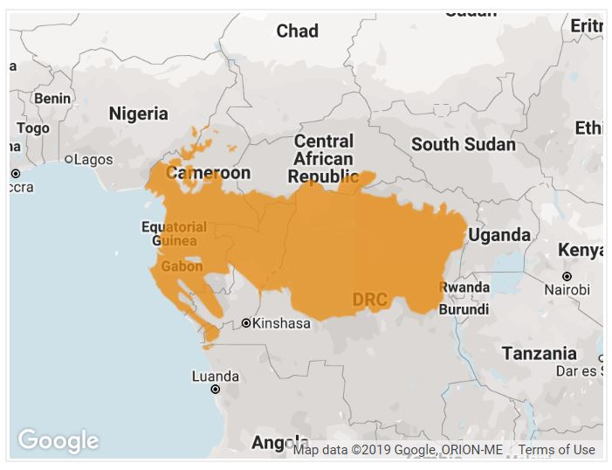
A mosaic of rivers, forests, savannas, swamps and flooded forests, the Congo Basin is teeming with life. Gorillas, elephants and buffalo all call the region home. The Congo Basin spans across six countries—Cameroon, Central African Republic, Democratic Republic of the Congo, Republic of the Congo, Equatorial Guinea and Gabon.
There are approximately 10, 000 species of tropical plants in the Congo Basin and 30 percent are unique to the region. Endangered wildlife, including forest elephants, chimpanzees, bonobos, and lowland and mountain gorillas inhabit the lush forests. 400 other species of mammals, 1,000 species of birds and 700 species of fish can also be found here.
The Congo Basin has been inhabited by humans for more than 50,000 years and it provides food, fresh water and shelter to more than 75 million people. Nearly 150 distinct ethnic groups exist and the region’s Ba’Aka people are among the most well known representatives of an ancient hunter-gatherer lifestyle. Their lives and well-being are linked intimately with the forest.

This tropical rainforest supports millions of people and is home to spectacular wildlife – but we’re not talking about the Amazon...
Africa has a green heart – a pulsing expanse of rivers and forests, rich in culture, wildlife and natural resources, with a vibrant population. The Congo Basin is the world’s second largest tropical rainforest, covering 2 million sq km – that’s an area roughly the size of Europe.

What’s at stake?
From rare butterflies to elephants and great apes, the Congo Basin’s forests support an amazing array of wildlife, provide food, water and shelter for 75 million people and store a huge amount of carbon.
Their destruction is unthinkable. Species – including our closest relatives the great apes – could become extinct. People already labouring under extreme poverty would not have the resources to survive. Climate change would accelerate, leading to similar destruction all over the world.

The story so far
A decade ago the unthinkable looked like it could become a reality.
Illegal and unsustainable logging, compounded by weak forest management, resulted in the destruction of more than 90,000 sq km of forests in central Africa between 1990 and 2000. Wildlife poaching was also rife, threatening species such as elephants, rhinos and gorillas.
By the turn of the millennium, the situation was critical. Something had to be done.
In 1999, we organized the Yaoundé Summit, a high level summit of heads of state from six Congo Basin countries. This led to the Yaoundé Declaration, where countries promised to cooperate to conserve the forests of the Congo Basin – the Green Heart of Africa.
In the last 10 years, they’ve done an amazing job. More than 10% of the forest is now covered by two massive conservation areas. Another 45,000 sq km is being managed sustainably, with Forest Stewardship Council certification. And at a second summit in 2005, the Democratic Republic of the Congo (DRC) committed to protecting another 150,000 sq km.

Did you know?
If the Congo basin’s forests disappeared, several species could become extinct. They include the bonobo or pygmy chimpanzee, and the okapi, a rare horse-like creature with a brown body and brown-and-white-striped legs.

Facts and stats
- 10% – amount of Congo Basin forests we’ve helped protect
- 75 million – number of people who depend on the Congo Basin for food and shelter
- 400 – mammal species found in the Congo Basin

What next?
We’re working tirelessly to make sure the green heart of Africa continues to beat and remain green – benefiting not only its own people and species, but the whole world.
Further forest summits are planned to reinforce and build on the regional conservation commitment. We hope to:
- expand the area of protected and certified forest
- improve protection for flagship species such as great apes and elephants
- put in place policies to make sure new infrastructure, such as roads and dams, is sustainable.

What you can do
- Illegal and unsustainable logging threatens the communities and wildlife of the Congo Basin. Support people and the environment by buying FSC-certified wood and paper products.
- Read more about our work in the Congo Basin
- Endangered mountain gorillas are only found in the Congo Basin.

Congo Basin
The Congo Basin contains 20 per cent of the world’s tropical forests – some 301 million ha – and makes up one of the most important wilderness areas left on Earth.
A mosaic of rivers, forests, savannahs, swamps and flooded forests, the Congo Basin forests span six countries – Cameroon, Central African Republic (CAR), Democratic Republic of Congo (DRC), Republic of the Congo, Equatorial Guinea and Gabon – that are home to unique species such as mountain and lowland gorillas, bonobos, okapis, chimpanzees and elephants.
Given the extent and rate of forest fragmentation from roadside farming and logging, basic simulations suggest that few large blocks of the region’s relatively undisturbed forest will remain in 50 years. In fact, it is estimated that up to 30% of forests will disappear by 2030.
In West and Central African countries, degradation of forests has already transformed some areas into savanna grasslands or degraded savannas.

The threat
Along with pressures caused by population growth over the last few decades, unregulated and often illegal extraction of timber puts wildlife, local people and economies at risk.
Unrelenting timber demand from around the world – in particular, rapidly rising demand from China -- means that the forests of Congo Basin are being harvested at unprecedented rates. Often, this is done unsustainably or not in accordance with local laws. Road-building by logging companies has also opened up remote areas of forests to poaching and illegal logging.

Congo Basin forest facts
- Congo Basin is home to the world's second largest tropical forest.
- The Congo Basin supports the highest biological diversity in Africa: over 400 mammal species and more than 1,000 bird species. It is the last stronghold for forest elephant, gorilla, forest buffalo, bongo, and okapi.
- Between 1990 and 2000, approximately 91,000 km2 of forests were lost in Central Africa, an area about three times the size of Belgium.
LATEST NEWS FROM THE CONGO BASIN
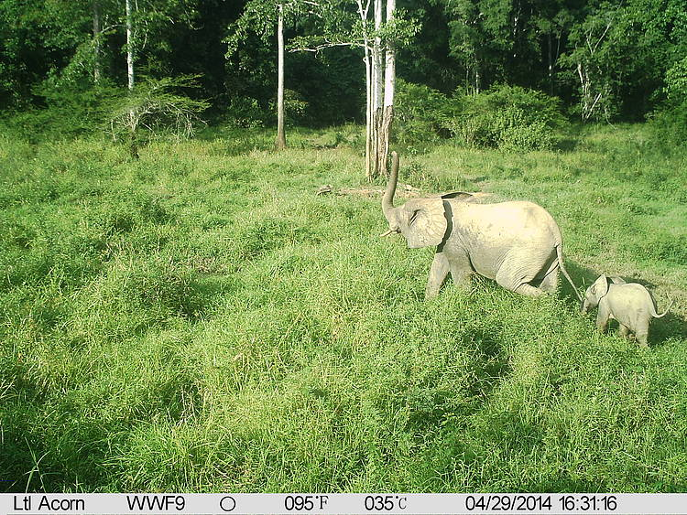
ThE SOLUTION
Concerted action that balances the rights of indigenous groups with market demands will be a critical element of conservation in the Congo Basin.
WWF and its partners are working throughout the region to create a network of protected areas to:
- conserve biodiversity,
- encourage logging and mining companies to promote good management practices,
- promote the reduction of greenhouse gas emissions from deforestation and degradation of forests,
- support sustainable business practices and financial investments in development and infrastructure projects,
- improve the livelihoods of indigenous and local peoples,
- reduce wildlife poaching and the bushmeat trade.

