[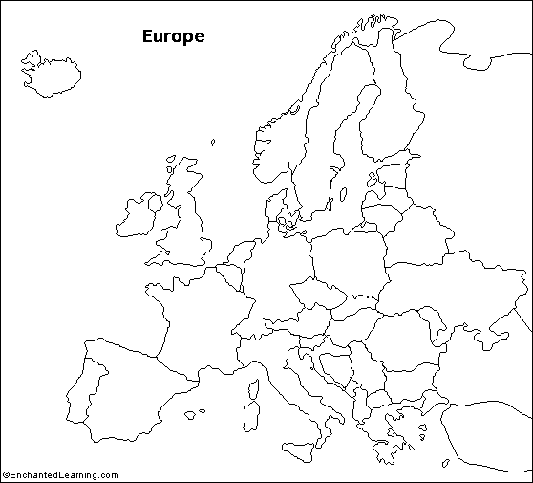](http://www.enchantedlearning.com/geography/europe/)