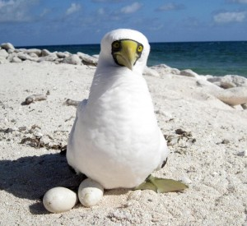
The Coral Sea is a marginal sea of the South Pacific off the northeast coast of Australia, and classified as an interim Australian bioregion.
It is bounded in the west by the east coast of Queensland, thereby including the Great Barrier Reef, in the east by Vanuatu and by New Caledonia, and in the northeast approximately by the southern extremity of the Solomon Islands. In the northwest, it reaches to the south coast of eastern New Guinea, thereby including the Gulf of Papua. It merges with the Tasman Sea in the south, with the Solomon Sea in the north and with the Pacific Ocean in the east. On the west, it is bounded by the mainland coast of Queensland, and in the northwest, it connects with the Arafura Sea through the Torres Strait.
The sea is characterized by its warm and stable climate, with frequent rains and tropical cyclones. It contains numerous islands and reefs, as well as the world's largest reef system, the Great Barrier Reef (GBR), which was declared a World Heritage Site by UNESCO in 1981.
Climate
The sea has a subtropical climate and is frequently hit by tropical cyclones, especially between January and April.
Annual rainfall typically ranges between 1,000 and 3,000 mm depending on the area. Most rains fall between December and March, in bursts of 30–60 days. The number of clear days per year varies approximately between 80 and 125, and the typical temperature variation through the year are 18–27 °C.
In January, the northwest monsoon may occur between the parallels of 15°S and 20°S, west of the 150°E meridian. Gales are rare in this region most of the year except for June–August, when strong southeasterly winds occur a few days per month.
The southeasterly trades are also strong north of 15°S between March and November. They weaken and often change to westerly winds in December and to northerly and northwesterly winds in January and February.^{[16]}

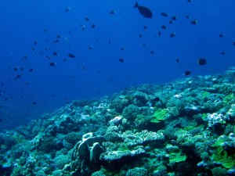
Human activities
The coastal areas of the Coral Sea were populated at least 40,000 years ago by prehistoric people descending through the northern islands. Those Aboriginal tribes have been dispersed and nowadays only about 70 groups live in the area around the GBR.
The sea was the location for the Battle of the Coral Sea, a major confrontation during World War II between the navies of the Empire of Japan, and the United States and Australia.
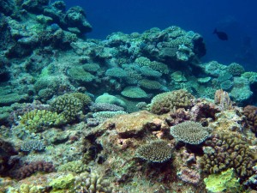
Navigation has long been a traditional human activity on the Coral Sea and there are 10 major ports on the Queensland coast alone. More than 3,500 ships operated in this area in 2007, making over 9,700 voyages that transported coal, sugar, iron ore, timber, oil, chemicals, cattle and other goods. The abundance of coral reefs hinders shipping traffic, and about 50–60 accidents per year were reported between 1990 and 2007 in the GBR alone.
Other economic activities in the sea include fishing and exploration of petroleum deposits in the Gulf of Papua. The sea is also a popular tourism destination. In 2006–2007, tourism on the GBR contributed A$5.1 billion to the Australian economy.^{[51]} The tourism is mostly foreign or from remote parts of Australia, with a local contribution of about A$153 million. In particular, about 14.6 million visits were made to the Coral Sea reefs by the Queensland residents over 12 months in 2008. Growing concerns over the environmental effects of tourism resulted in establishment in 1975 of the Great Barrier Reef Marine Park. There are also smaller state and national parks. In 1981, the Great Barrier Reef was declared a World Heritage Site by UNESCO. From the middle of 2004, approximately one-third of the GBR Marine Park is protected from species removal of any kind, including fishing, without written permission.
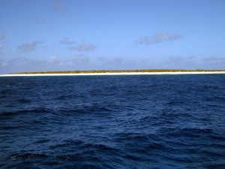
It was suggested in 1923 that the Great Barrier Reef contains a major oil reservoir. After the Commonwealth Petroleum Search Subsidies Act of 1957, hydrocarbon exploration increased in Queensland, including a well drilled at Wreck Island in the southern Great Barrier Reef in 1959. In the 1960s, drilling for oil and gas was investigated throughout the Great Barrier Reef, in the Torres Strait, along "the eastern seaboard of Cape York to Princess Charlotte Bay" and along the coast from Cooktown to Fraser Island. In the late 1960s, more exploratory oil wells were drilled near Wreck Island in the Capricorn Channel, and nearDarnley Island in the Torres Strait, but with no results. In the 1970s, responding to concern about oil spills, the Australian government forbade petroleum drilling on the GBR. Yet oil spills due to shipping accidents are still a threat to environment, with a total of 282 spills between 1987 and 2002.

