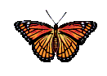
Organism | 1 | 2 | 3 | 4
Common Name | Orange-barred  sulphur | Orange-barred  protea | Green-spotted  flambeau | Silver-studded  blue
Class | Insecta | Insecta | Insecta | Insecta
Order | Lepidoptera | Lepidoptera | Lepidoptera | Lepidoptera
Family | Peridae | Lycaenidae | Nymphalidae | Lycaenidae
Genus | Phoebis | Capys | Agraulis | Plebejus

- According to the classification chart above, which two organisms are most closely related? Explain your answer.

- Compare the classification of the Orange-barred sulphur (1) to the Orange-barred protea (2).

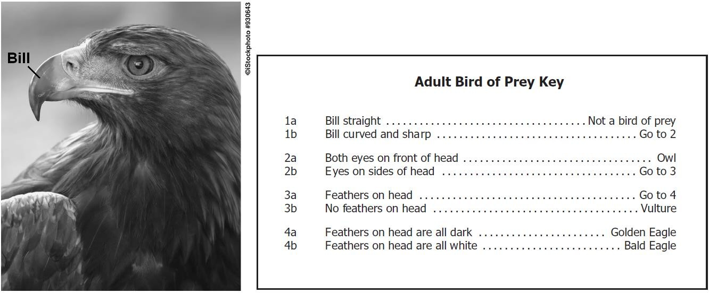

- Based on the image and the dichotomous key above, which type of adult bird is shown?

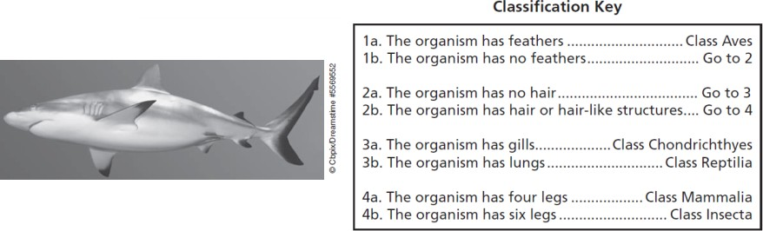

- An organism like the one shown above is caught in a net. Using the dichotomous key above, identify the organism’s class.

- Fill in the correct Kingdoms into the Dichotomous key below.
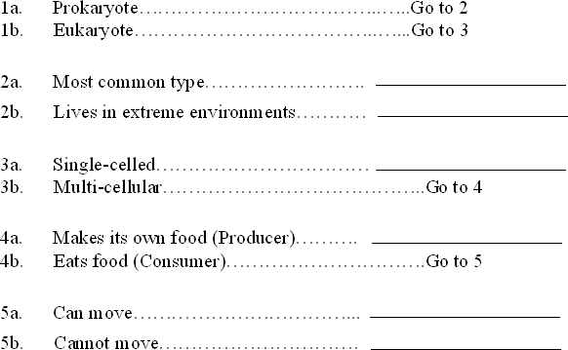

- Using the Dichotomous key above, identify in which Kingdom the organisms below belong.
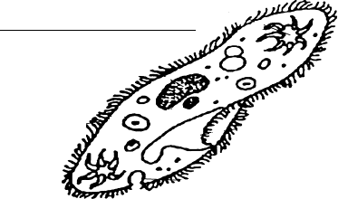
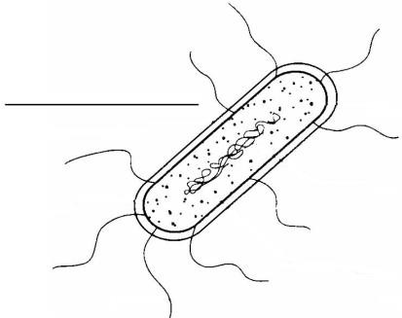

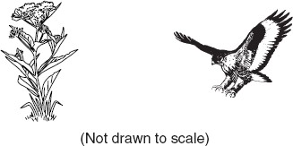
- Compare the levels of classification of the two organisms shown to the right.

- Which classification group contains organisms that have the most characteristics in common?

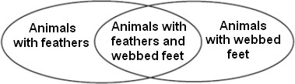

- During science class, a student identified characteristics of a few organisms. The student created the Venn diagram above using the characteristics. What was the student attempting to do?

- The table below shows characteristics of four organisms. Using the information, identify which kingdom each organism most likely belongs. Explain your answer using evidence from the data table.
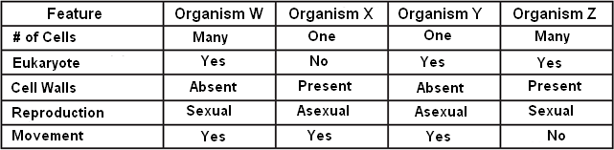

Each characteristic below can be used to describe a specific Kingdom. Place the characteristics into the chart based on all of the Kingdoms they describe.

- archaebacteria | - eubacteria
- has a nucleus | - eukaryote
- does not have a nucleus | - prokaryote
- decomposer | - makes its own food
- consumer | - many cells (multi-cellular)
- producer | - contains cell walls
- contains chlorophyll | - absorbs nutrients
- single-celled (unicellular) | - lives in harsh environments
- contains the oldest forms of life on earth | - classified based on how it gets energy
- Reproduces asexually | - Reproduces sexually

Kingdom | Characteristic
Bacteria
Protist
Fungi
Plant
Animal

