Chapter 4 Virtual Investigation (under eactivities)
(my.hrw.com/username: lostmountain/password: a3j3b)

STAGE 1

______1. In addition to sunlight, what else does the plant need for photosynthesis?
(select all that apply)
A. Oxygen (O₂) B. Carbon dioxide (CO₂) C. Water (H₂O)
______2. After a glucose (C₆H₁₂O₆) molecule is produced from 6 CO₂ and 6 H₂0. What is left over?
A. Hydrogen B. Oxygen C. Carbon D. None of the above

3. Fill in each square with one of the following terms: CO₂, O₂, energy from light, energy from food, C₆H₁₂O₆, H₂O
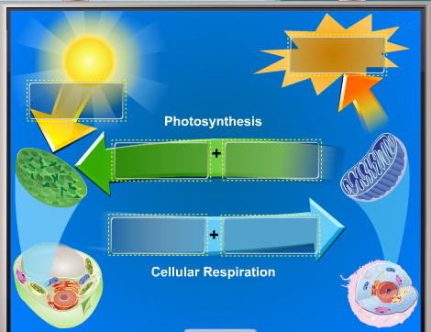

STAGE 2
4. Place the slide letter by the correct cell cycle.
______Interphase
______Prophase
______Metaphase
______Anaphase
______Telophase
______Cytokinesis

When you are finished go to the following sites:
- Brainpop.com (username: lostmountain/password: education). Search for each of the following:
  - Mitosis: play the “Control of the Cell Cycle” game under the GAMEUP section.
  - Diffusion: click on the FYI section and read the information under each circle icon. Write a summary paragraph on the back of this paper about what you read from the “In-Depth” icon.
  - Passive Transport: click on the FYI section and read the information under each circle icon. Write a summary paragraph on the back of this paper about what you read from the “In-Depth” icon.
  - Active Transport: click on the FYI section and read the information under each circle icon. Write a summary paragraph on the back of this paper about what you read from the “Did You Know” icon.
- CellsAlive.com and select Mitosis under the Interactive section. View the animation and scroll down to read what is written about each phase.

