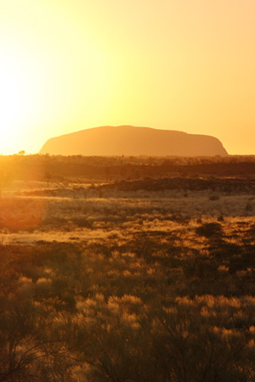
Ayers Rock is one of the most impressive landmarks in Australia. A huge chunk of sandstone and a ‘true’ monolith, it resides in Uluru-Kata Tjuta National Park. Ayers Rock is located down towards the southwest corner of the Northern Territory and close to the geographic centre of Australia.

Learn about Ayers Rock
The rock is huge, jutting up about 350m from its barren surrounds. And more interestingly, Ayers Rock extends even further than this amount below ground. Although there are other, similar entities to Ayers Rock – most notably the nearby Olgas and Mount Augustus in Western Australia – it is the only singular monolith with its composition.
A World Heritage site, Ayers Rock also goes by the Aboriginal name of Uluru. Aboriginal tribes were living in the area 10,000 years ago. White men did not come onto the scene until the 1870s, when William Gosse named it for Henry Ayers, the then-South Australia Chief Secretary. Ayers Rock is sometimes incorrectly written as Ayres Rock, Ayes Rock, Ares Rock, Eyers Rock, Eyres Rock, Aires Rock and Airs Rock. The Pitjantjatjara Aboriginals own the land around and about Ayers Rock today.
Ayers Rock is about 335kms to the southwest of Alice Springs – 463kms by road, about five hours – and is served by the small resort town of Yulara. This is where tourists stay ad most people spend the night, either in hotel accommodation or camping; there are no actual camping or other facilities within the park itself.
Visitors can climb Uluru – Ayers Rock as well as explore the base of it, which is around 10kms by footpath. The trip up takes a good couple of hours there and back. Although if you’re fit and hotfoot it, it can be done in 20 or 30 minutes (not recommended in the summer). It’s best to observe the rock during sunrise and sunset, when its terracotta hue morphs into a violet/blue tinge.

What is Ayers Rock?
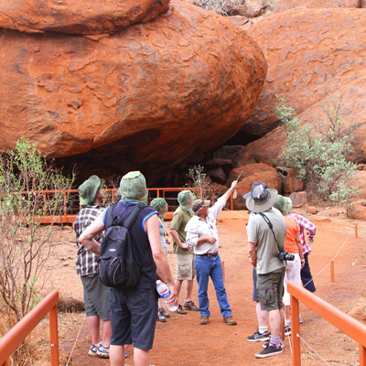
Ayers Rock comprises of a single piece of rock, almost 10kms in circumference and jutting out of the Northern Territory Outback. There is no other known geological feature in the world exactly like it, so it’s certainly considered a natural wonder and attracts the crowds to prove it.
For decades, tourists have been making the long journey to this remote site trying to find out just exactly what is Ayers Rock all about. Thousands of visitors travel some 460kms southwest of Alice Springs to see this remarkable lump of orange/brown sandstone that uniquely rises 350m from the flat plains of spinifex grass. Only the nearby Kata Tjuta, also known as The Olgas, offer anything similar in the region. Unlike Ayers Rock, they comprise of several sandstone mounds, which further add to the attraction of the area.
Ayers Rock is also known as Uluru, the name given to it by the local Pitjantjatjara Aboriginal tribe long before surveyor William Gosse named it in honour of South Australia Chief Secretary Henry Ayers in 1873. Today, the Aborigines own and administer the land on which the rock stands and, since they attach spiritual significance to it, they prefer visitors not to climb it.
A trip to Ayers Rock usually involves a five-hour drive from Alice Springs, in addition to a flight or an even longer drive, and therefore most people stay overnight. This is usually done in campsites or local resorts. One of the highlights of a visit is experiencing the changing colours of the rock at sunset and sunrise. At midday, temperatures can top 35°C during the summer months, so it’s best to plan to be indoors at the local Yulara resort town at this time..
Where is Ayers Rock? It is roughly slap-bang in the centre of Australia, although it is somewhat confusingly classified as within the Northern Territory. The state, however, extends beyond the centre of the country, and Ayers Rock can be found towards its southwest corner. It is part of Uluru National Park, an area set up to protect Ayers Rock and The Olgas.
The rock sits right in the middle of the national park, about 335kms southwest of Alice Springs. People usually get here by road from Alice (463kms), but there is also an airport nearby. About 20kms to the north of Ayers Rock is where visitors will find the service town of Yulara.
Ayers Rock itself is a World Heritage site within a World Heritage area. Motorists can get here by taking the Lasseter Highway from Yulara, which connects with the Stuart Highway from Alice Springs. The Lasseter Highway then spurs off to Ayers Rock and continues on to The Olgas (Kata Tjuta).
By road, the journey from Alice Springs is 200kms south along the Stuart Highway, another 245kms west along the Lasseter Highway, and then another 20kms south to Ayers Rock. There’s not much of interest along this route, but even less for those who head up from South Australia through Coober Pedy.
Tourists can hire cars in Alice Springs for the five-hour drive, and the entire trip can be done in one day if necessary. This is not recommended, however, and most people opt for a bus tour due to where Ayers Rock is – the middle of nowhere.

