Governments of Africa | Kenya | Nigeria | South Africa
Flag | 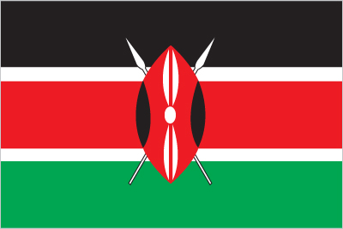 |  | 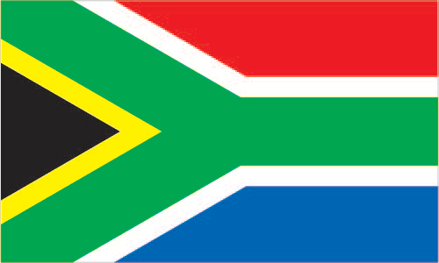
Type of Government: | Presidential democracy  (also a republic) | Presidential democracy  (also a republic) | Parliamentary democracy  (also a republic)
Level of Citizen Participation (autocratic, democratic): | Democratic | Democratic | Democratic
Head of Government (Title, Name, and Picture): | President Uhuru Kenyatta  (since 9 April 2013)  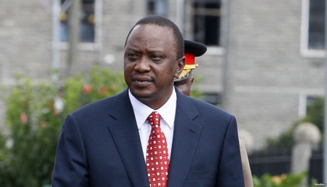 | President Muhammadu BUHARI (since 29 May 2015)  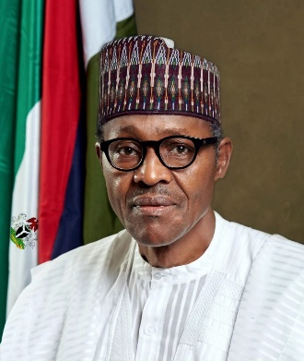 | President Cyril Ramaphosa  (since 15 February 2018)  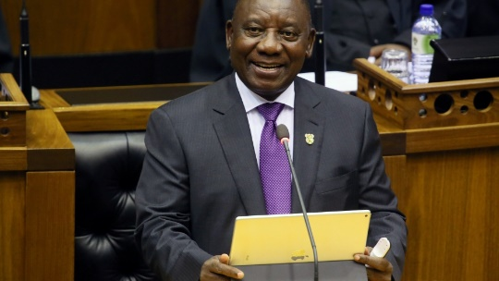
 | Kenya | Nigeria | South Africa
How is the head of government chosen? | Elected by popular vote | Elected by popular vote | Elected by National Assembly (legislature)
Duration of term for head of government: | 5 year term (can serve 2 terms) | 4 year term (can serve a second term) | 5 year term (can serve second term)
Voting Rights: | Universal suffrage at 18 years of age | Universal suffrage at 18 years of age | Universal suffrage at 18 years of age
Additional Info (under “People and Society”): | Life expectancy rate: 64.6 years  Literacy rate: 78%  HIV/AIDS rate: 4.8% (number 12 in the world)  School Life Expectancy:  Total: 11 years  Male: 11 years  Female: 11 years | Life expectancy rate: 59.3 years  Literacy rate: 59.6%  HIV/AIDS rate (prevalence): 2.8% (number 20 in the world)  School Life Expectancy:  Total: 9 years  Male: 9 years  Female: 8 years | Life expectancy rate: 64.1 years  Literacy rate: 94.4%  HIV/AIDS rate (prevalence): 18.8%  (number 4 in the world)  School Life Expectancy:  Total: 13 years  Male: 12 years  Female: 13 years

