T h e C o l d W a r Name

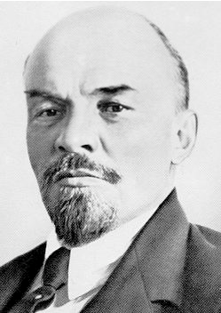In 1917, the Bolshevik Revolution eliminated rule by the czar’s family and established rule by the communist party in Russia. The leader of the Bolsheviks was Vladimir Lenin (see top right photo ⇒). Russia renamed the territory it controlled the
Union of Soviet Socialist Republics, or the U.S.S.R. for short. Upon his unexpected death in 1924, the Russian communist party was taken over by Josef Stalin (lower photo). “Uncle Joe,” as he was called in the U.S. as our ally during World War II, remained the leader of the USSR until his death in 1953.

R e v i e w : What is capitalism? Capitalism is an economic system in which citizens own private property and are entitled to profit from it. In a capitalist country, almost all the natural resources, factories, mines and land are owned by individuals. They keep the profits from what they own.

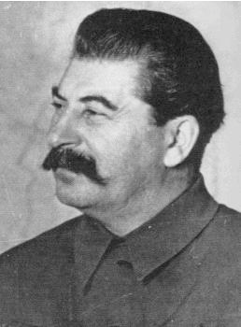R e v i e w : What is communism? Communism is an economic system in which the people as a whole own all the natural resources, factories, mines and land of their country. In theory, all citizens profit from the resources of a country. In practice,
the government owns everything, sets all prices, employs everyone, and distributes all profits.

The U.S.S.R. stands for the
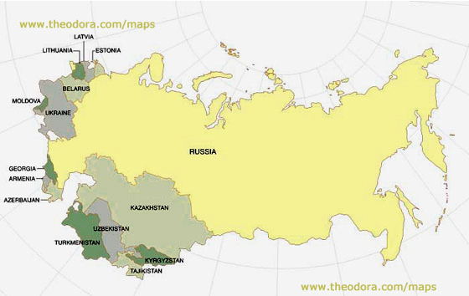Union of Soviet
Socialist Republics.
List the 15 republics that made up the
“Soviet Union.”
1. Russia
2. Ukraine
3. Belarus
4. Lithuania
5. Latvia
6. Estonia
7. Armenia
8. Moldova
9. Georgia
Map courtesy of www.theodora.com/maps, used with permission. 10. Uzbek S.S.R.
11. Kazakh S.S.R.
12. Azerbaijani S.S.R.
13. Kirghiz S.S.R.
14. Tajik S.S.R.
15. Turkmen S.S.R.

“The Cold War” was the rivalry between the communist USSR (and its allies) and the democratic, capitalist USA (and its allies) between 1945 and 1991, in which both contributed to wars in other countries to gain allies.

The main danger from conflicts during the Cold War was nuclear proliferation—the spread of nuclear technology—and the nuclear arms race between the USA and the USSR !
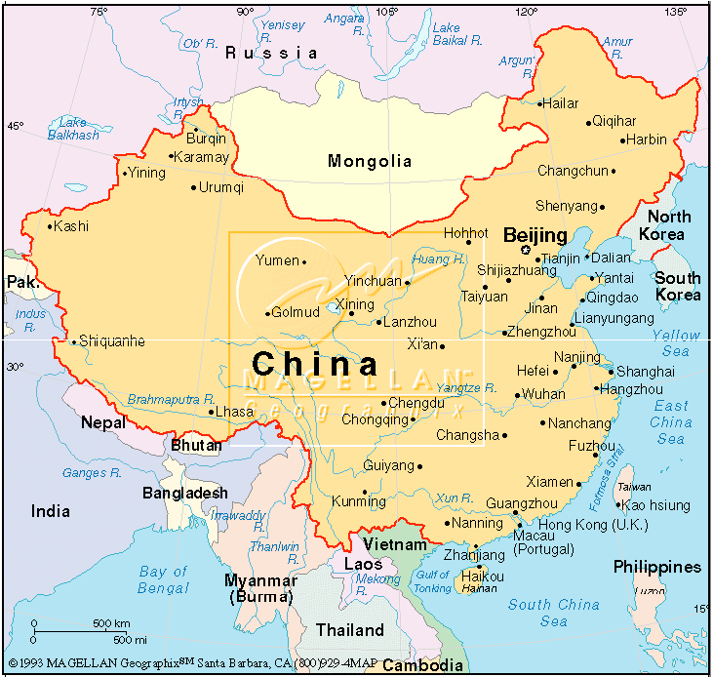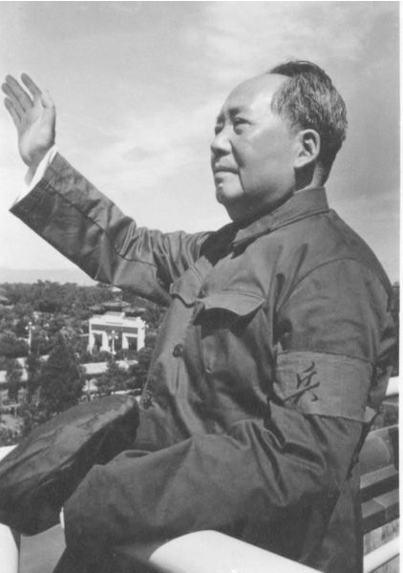FYI: China, the USSR’s neighbor to the south, became a communist nation in 1949, just after WWII. At first, the two nations were allies. However, the Soviet Union and China had border disputes; Stalin and Mao Zedong (photo, left) also had ideological differences about how communism should be practiced because China was
more agricultural and Russia was more industrialized. By 1960 the two nations were no longer allies.

the “iron curtain”

(this means the division of European countries into Eastern communist vs. Western capitalist)

“From Stettin in the Baltic to Trieste in the Adriatic,
an iron curtain has descended across the continent”—Winston Churchill, 1946

Label Stettin on the Baltic Sea and Trieste on the Adriatic Sea.

Draw the “iron curtain”
across Europe.

Nations on the West of the “iron curtain” joined an alliance of capitalist, democratic countries.

Nations on the East of the “iron curtain” joined an alliance of communist countries.

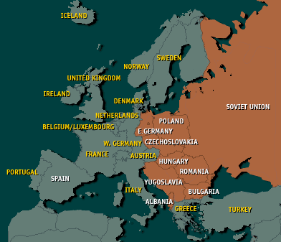Map courtesy of CNN.com;
http://www.cnn.com/SPECIALS/cold.war/episodes/03/maps

the NATO alliance was formed in 1949. N.A.T.O. means North Atlantic Treaty Organization. Its 16 original members were:
1. the United States | 7. | Luxembourg | 13. Greece (1952)
2. the United Kingdom | 8. | the Netherlands | 14. Turkey (1955)
3. France | 9. | Denmark | 15. West Germany (1955)
4. Canada | 10. | Norway | 16. Spain (1982)
5. Iceland | 11. | Italy
6. Belgium | 12. | Portugal

The thing NATO countries have in common is: they’re not communist.

the Warsaw Pact alliance was formed in 1955.
Warsaw was the communist capital of Poland. The Warsaw Pact was made up of 8 nations:
1. the USSR 5. East Germany
2. Poland 6. Romania
3. Czechoslovakia 7. Bulgaria
4. Hungary 8. Albania
The thing Warsaw Pact nations had in common was: they’re communist.

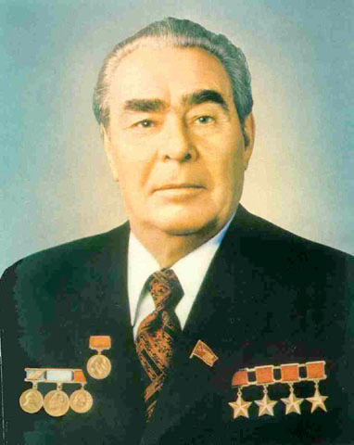⇒ and now it’s time to protect your turf …
Lenoid Brezhnev (photo, right) was the Soviet head of state from 1964 to 1982.
He enacted the Brezhnev Doctrine:
If anyone threatened the communist party’s monopoly in Soviet satellite nations, the USSR would interfere with political and military force.

A policy known as brinksmanship developed, in which each side would push the other side to the “brink” of war, in order to show that their threats were serious. The goal was to get the enemy to back down, making your side seem more powerful, without actually going to war.

T h e “ h o t ” w a r s w i t h i n t h e “ c o l d w a r ”

Whenever a nation had a civil war in which one side was communist,
the U.S.S.R. (or China) would give military aid, training and equipment to the communist side in hopes that they would win and communism would spread to more and more countries. The United States would side with whoever was fighting against the communist party, giving military aid, training and equipment to the political or military groups opposing communism.

Here are some examples:

1. Greece and Turkey, 1947 (beginning of the Truman Doctrine)

2. Berlin Airlift 1948-1949 (10 months)
3. Korean War, 1950-1953. Result: Korea split along the 38th parallel into two countries, communist North Korea and democratic, capitalist South Korea.

4. Space Race in the 1950s and 1960s: The USSR won the first two rounds with the first artificial satellite (Sputnik, 1957) and the first man in space orbiting
the Earth (Yuri Gagarin, 1961). The United States ultimately “won” with the first man on the moon (Neil Armstrong) in 1969.

5. Hungarian Revolution 1957
(Can use excerpts from The Bridge at Andau by James Michener, published in
1957.) Brutal response to Hungarians attempting to oust communism.
This is the clear pattern for the Brezhnev Doctrine, which was not formed until
1968. Similar actions were taken during the Soviet invasion of Czechoslovakia in
1968 and the Soviet invasion of Afghanistan in 1979.

6. Berlin Wall Built, August 13, 1961. Twenty-eight mile-long barrier around
West Berlin, to keep the brain drain and labor force drain from happening to the more economically successful West. (Draw a map of West/East Germany,
place Berlin in East Germany, show its East/West divisions, and draw the Wall around it.) This will need to be done thoroughly in order for page 5 events from 1989 to make sense.

7. Cuban Missile Crisis, October 16-28, 1962.

8. Vietnam War 1965-1975. Result: Vietnam is united as a communist country.

9. Ethiopia (communist) vs. Somalia, 1977. Result: Ethiopia won.

10. Civil Wars in Africa:
• Zimbabwe, communist control since independence from Britain in 1980
• Angola, communist control since independence from Portugal in 1975; civil war is essentially still ongoing
• Mozambique, independence from Portugal in 1975, allied with the Soviet Union

The Cold War started to thaw in 1985 when Mikhail
Gorbachev (photo, left) became the Soviet Premier (Communist Party
Secretary, Head of State). He began a program with two major changes:

1. Glasnost: political openness (freedom of speech and of the press)

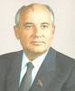2. Perestroika: economic restructuring (citizens can own their own business)

…this political and economic restructuring caused:

• greater freedom of speech, so publications and individuals could say what they thought without fear of arrest
• political prisoners were released, since their “crimes” of speaking against the government were no longer illegal
• inflation skyrocketed and black markets flourished
• multi-party elections began

In 1989 Gorbachev repudiated the Brezhnev Doctrine. As a result, a series of amazing events took place…1989 became known as the “Year of Miracles.”

In Hungary…parliament voted to allow freedom of speech, hold free elections, and take down the barbed-wire fence with Austria (the iron curtain coming down!); thousands of East Germans flee through the newly-opened borders into the West

In Poland…Solidarity swept the free multi-party elections (winning 99 seats out of 100) and the Polish communist party is ousted.

In East Germany…demonstrations at the Berlin Wall grow to half a million people, shouting “We want out! We’re staying here!” Border guards open the gates; East Germans are free to cross for the first time in 28 years—huge celebrations ensue. With open borders between East and West, there is no need for the Berlin Wall.

The Communist Party in the Soviet Union lost a majority in the elections in June 1991. We call this “the Collapse of the Soviet Union.”

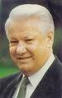In these elections, Boris Yeltsin became Head of State in the newly renamed
“Russian Soviet Federated Soviet Republic.” Immediately, these events happened:

• September 6: Estonia, Latvia and Lithuania declared independence.
• December 1: Ukraine declared independence

By December 8, 1991 all 15 republics of the “former Soviet Union” were independent. On December 26, 1991 the USSR was officially dissolved and…

the cold WAR WAS OVER!

