7th Grade General Supply List 2019-2020
2 inch - 3-ring Binder for organization to support all classes
4 – Three-prong folders with pockets (3 for Social Studies & 1 for Language Arts)
10 – File Folders (Science)
2 – Clear Sheet Protectors (Social Studies)
2 Composition books (no spiral) – (Math & Language Arts)
3 Packs loose-leaf paper (college ruled)
Graph Paper
5 Glue Sticks
Pair of scissors
1 Pack of 5 different colored Hi-lighters
2 Packs of 100 post-its
Blue, Black, and Red pens
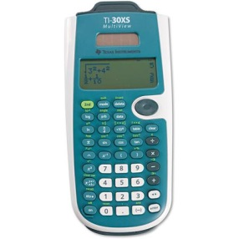
Pencils
Pencil Pouch
Hand-held pencil sharpener
Colored Pencils
Dry-erase markers (at least two)
1 – 100 pack of index cards
Calculator – TI-30 XS Multi-view is the recommended calculator
7th Grade Donation List
Tissues Hard Candy Paper towels Markers
Hand sanitizer Sanitizer wipes Dry Erase Markers
*Several of the 7th grade teachers will have Bring Your Own Device (BYOD) classrooms this year. We will provide more information once the school year starts.

