Name: ______________________________________ Date: __________ Period: _____
Microscope online:
1. Open your internet browser and go to http://sciencespot.net/.
2. Click the Kid Zone graphic in the upper right-hand corner.
3. Click “Cells & Microscopes” to find the links you need.
4. Visit the sites listed below and record the requested items from each site. You will turn in your paper to Mrs. Puckett at the end of the class period.
1-Virtual Electron Microscope (list 3 things you learned)
a. ____________________________________________________________
b. ____________________________________________________________
c. ____________________________________________________________

2-A-Z Microscope History (list 3 things you learned)
a. ____________________________________________________________
b. ____________________________________________________________
c. ____________________________________________________________

3-MicroAngela’s Gallery (list 5 organisms that you viewed and write a brief description of each)
a. ____________________________________________________________
b. ____________________________________________________________
c. ____________________________________________________________
d. ____________________________________________________________
e. ____________________________________________________________

4-Quia-Microscope Mania Game (record each game you played and how
well you did)
a. ____________________________________________________________
b. ____________________________________________________________
c. ____________________________________________________________
d. ____________________________________________________________

5-Microscope Parts & Functions Quiz (record score) _____________________

If you finish the above activities, go to BrainPop.com. Follow the instructions on the card below to log in and sign up. Your user name should be your first name.last name (john.smith). Your password should be your lunch number. Once logged in search for microscopes. Under the games section, click on Virtual Labs: Using the Microscope. Complete the virtual lab. Once you are finished with the virtual lab click on the game quiz and complete the game quiz. Once you are finished with the game quiz your will need to click on the submit button to submit your score.
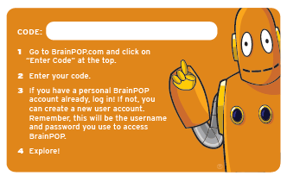
Lifescience6

