Name: ______KEY____________________________________ Date: ___________ Period: _________
Cells & Genetics

Description: Cells and Genetics refers to differentiating between the component parts of cells and understanding their functions and interactions, categorizing groups of cells and recognizing the functions and interactions of these groups, identifying the roles of genes and chromosomes in reproduction, and comparing and contrasting types of reproductive processes.

Cell Background
- The cell is the structural and functional unit of all known living organisms.
- It is the smallest unit of an organism that is classified as living, and is sometimes called the building block of life.
- Most organisms, such as most bacteria, are unicellular (consist of a single cell).
- Other organisms, such as humans, are multicellular.

EXPECTED CRCT KNOWLEDGE
- Demonstrate understanding of how cells take in nutrients in order to grow, divide, and make needed materials. (Pg. 90-101)
  - Cells take in nutrients through the cell membrane.
    - _________PASSIVE TRANSPORT____________ (no energy needed)
      - ____DIFFUSION______: molecules naturally move from areas where there are many (high concentration) to areas where there are few (low concentration). Oxygen moves in and out of the cell this way.
      - ___OSMOSIS______: Name used for the diffusion of water molecules.
    - ____ACTIVE TRANSPORT________________ (energy needed)
      - ___ENDOCYTOSIS__________: taking in a particle. (glucose)
      - __EXOCYTOSIS___________: getting rid of a particle. (waste)
  - Cells need nutrients in order to grow and make needed materials.
    - _______CELLULAR RESPIRATION_________________ (ANIMALS)
      - Glucose + Oxygen → Chemical Energy + Water + Carbon Dioxide
    - ______PHOTOSYNTHESIS__________________ (PLANTS)
      - Light Energy + Water + Carbon Dioxide → Glucose + Oxygen
  - Cells Divide.
    - ___MITOSIS___________ (happens in all eukaryotic cells b/c they have a nucleus)
      - Cell grows and carries out normal functions; organelles duplicate.
      - DNA replicates.
      - Chromosomes condense.
      - Chromosomes line up.
      - Chromosomes separate.
      - Nuclei form.
    - ____BINARY FISSION________________ (happens in all prokaryotic cells)
- Correlate cell structures to basic cell function. (Pg. 60-79)
Organelle | Function | Real World Analogy
Cell Membrane | BOUNDARY BETWEEN INSIDE AND OUTSIDE, CONTROLS ENTRANCE AND EXIT FROM THE CELL | CITY WALL
Nucleus | DIRECTS CELL FUNCTIONS | CITY HALL/BRAIN
Cytoplasm | GEL LIKE SUBSTANCE THAT FILLS THE CELL AND CONTAINS THE ORGANELLES | INSULATION
Chloroplast | USES SUNLIGHT IN THE PROCESS OF PHOTOSYNTHESIS | SOLAR PANEL
Mitochondria | PRODUCES THE CELLS ENERGY | POWER PLANT

- Categorize cells and groups of cells by levels of cellular organization.

Cells → __TISSUES____ → ___ORGANS___ → Organ Systems → Organisms → ___POPULATION_____ → Community → Ecosystem → __BIOME____→ Biosphere (Earth)

- Explain the role of the functions of the tissues, organs, and major organ systems in the human body and demonstrate understanding of the interactions of these systems. Pg. 580-582
System | Function
Skeletal Pg. 584 | PROVIDES SUPPORT FOR THE BODY AND PROTECTS ORGANS
Muscular Pg. 588 | ALLOWS THE BODY TO MOVE
Respiratory Pg. 620 | PROVIDES THE BODY WITH OXYGEN
Digestive Pg. 634 | CONVERTS FOOD INTO NUTRIENTS BODY USES FOR ENERGY
Urinary Pg. 642 | ELIMINATES WASTE
Circulatory Pg. 606 | DELIVERS NUTRIENTS AND OXYGEN TO BODY-HELPS ELIMINATE WASTE
Immune Pg. 714 | PROTECTS THE BODY FROM DISEASES
Nervous Pg. 656 | CONTROLS THE ACTIONS OF THE BODY
Integumentary Pg. 592 | PROVIDES A COVERING FOR THE BODY-HOLDS EVERYTHING IN
Endocrine Pg. 670 | REGULATES THE BODY WITH HORMONES

Process | Other Systems it Interacts with | Description of Interaction
Digestion  Pg. 634 | CIRCULATORY, URINARY, MUSCULAR | CIRCULATORY DELIVERS NUTRIENTS, URINARY GETS RID OF WASTE, MUSCULAR MAKES SYSTEM WORK
Respiration  Pg. 620 | CIRCULATORY, MUSCULAR | CIRCULATORY DELIVERS OXYGEN, MUSCULAR MAKES SYSTEM WORK
Circulation  Pg. 606 | MUSCULAR, DIGESTIVE, RESPIRATORY | MUSCULAR MAKES SYSTEM WORK, DIGESTIVE PROCESSES NUTRIENTS, RESPIRATORY PROVIDES OXYGEN
Excretion/Urinary  Pg. 642 | MUSCULAR, DIGESTIVE | MUSCULAR MAKES SYSTEM WORK, DIGESTIVE CREATES WASTE AS IT PROCESSES NUTRIENTS
Movement/Muscular  Pg. 588 | SKELETAL | SKELETAL PROVIDES SUPPORT THAT HELPS MUSCLES MOVE
Control/Nervous  Pg. 656 | ENDOCRINE | ENDOCRINE SYSTEM CONTROLS BODY WITH HORMONES-NERVOUS SYSTEM GIVES THE COMMANDS
Skeletal  Pg. 584 | MUSCULAR | MUSCULAR SYSTEM HELPS SKELETAL SYSTEM TO MOVE
Lymphatic  Pg. 616 | CIRCULATORY | CIRCULATORY HELPS TO ELIMINATE EXCESS WASTE PRODUCED BY LYMPHATIC SYSTEM
Endocrine  Pg. 670 | NERVOUS | NERVOUS SYSTEM GIVES COMMANDS TO THE ENDOCRINE SYSTEM

Genetics Background: Genetics is the science of heredity and variation in living organisms. Knowledge of the inheritance of characteristics can be used for improving crop plants and animals through selective breeding. The modern science of genetics, which seeks to understand the mechanisms of inheritance, began with the work of Gregor Mendel in the mid-1800s. Mendel observed that inheritance is a fundamental process with specific traits that are inherited in an independent manner — these basic units of inheritance are now called genes. Pg. 114
- Explain the role of genes and chromosomes in the process of inheriting a specific trait.
  - A gene is a unit of heredity that occupies a specific location on a chromosome and codes for a particular trait.
  - A chromosome is the physical structure in a cell that contains the cell’s genetic material.
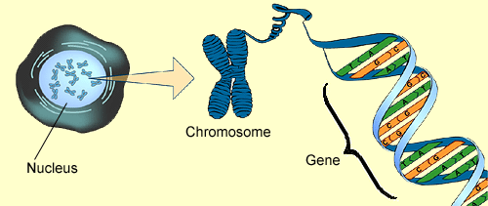
  - Alleles are various forms of the same gene.
Mendel crossed a homozygous tall pea plant with a homozygous short pea plant. What are the expected genotypes and phenotypes of the offspring? List as a probability. (create a Punnett Square)
TT X tt 100% Tt Tall

Mendel then crossed two of the offspring from above. What are the expected genotypes and phenotypes of this second generation of offspring? List as a probability. (create a Punnett Square)
Tt x Tt
Genotypes
TT-25% Tall Tt-50% Tall tt-25% Short 75% Tall 25% short

- Compare and contrast asexual and sexual reproduction for organisms.
Sexual
Pg
Asexual

Pg. 126
Pg. 100

1 parent
Offspring Identical
Mitosis (body cells)
2 parents
Produce offspring
Offspring varied
Meiosis

For each type of organism, place a check in the reproduction column that pertains to them. Also give an example of a specific organism.
Organism | Archaea | Bacteria | Protista | Fungi | Plants | Animals
Do not have nuclei | x | x
Have specialized sense organs |  |  |  |  |  | x
Have cell walls |  |  |  |  | x
All eukaryotes that are not plants, animals, or fungi |  |  | x
Break down material outside their bodies |  |  |  | x
Usually green |  |  |  |  | x
Mold |  |  | x | x
All are single-celled | x | x
Algae |  |  | x
Complex organisms with no cell wall |  |  |  |  |  | x
Prokaryotes that may be found in the human body |  | x

7.Demonstrate understanding that selective breeding can produce plants or animals with desired traits. Pg. 132
Selective breeding is the process of developing a cultivated breed over time, and selecting qualities within individuals of the breed that will be best to pass on to the next generation. Charles Darwin discussed how selective breeding had been successful in producing change over time in his book, Origin of Species. The first chapter of the book discusses selective breeding and domestication of such animals as pigeons, dogs and cattle. Selective breeding was used by Darwin as a springboard to introduce the theory of natural selection, and to support it.
Critical Thinking Question: Give two examples of how selective breeding has been beneficial to humans. Give one example of how selective breeding can be harmful to the animal. ANSWERS WILL VARY

Interdependence of Life

Description: Interdependence of Life refers to recognizing the relationships that organisms have with themselves, each other, and their environments, understanding food webs and how environmental change and competitive and beneficial relationships affect individual organisms and entire species, and comparing and contrasting Earth’s major terrestrial and aquatic biomes.
Ecology Background: Ecology is the scientific study of the distribution and abundance of life and the interactions between organisms and their environment. The environment of an organism includes physical properties, which can be described as the abiotic factors such as sunlight, climate, and geology, and biotic factors, which are other organisms that share its habitat.

- Evaluate how matter is transferred in a food web from one organism to another.
Draw a food web. (Pg. 486)
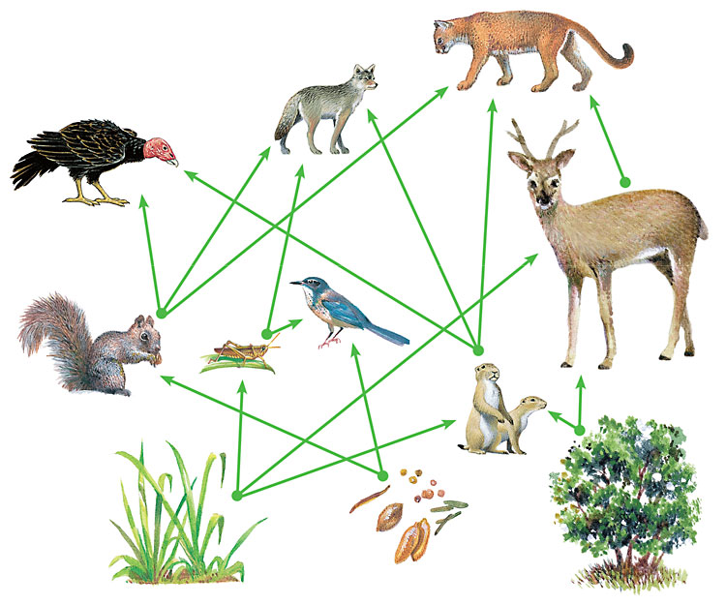
Explain how matter is transferred in your food web. Use the following terms: sun, producer, consumer, decomposer, autotroph, heterotroph, and 10%.

- Demonstrate understanding of how matter can recycle between organisms and their environments.
Draw a diagram of water cycling through organisms and their environment. (Pg. 508-510)
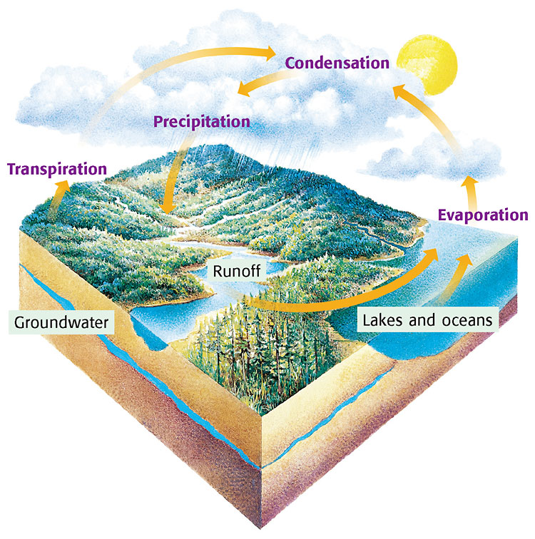

Draw a diagram of carbon cycling through organisms and their environment.
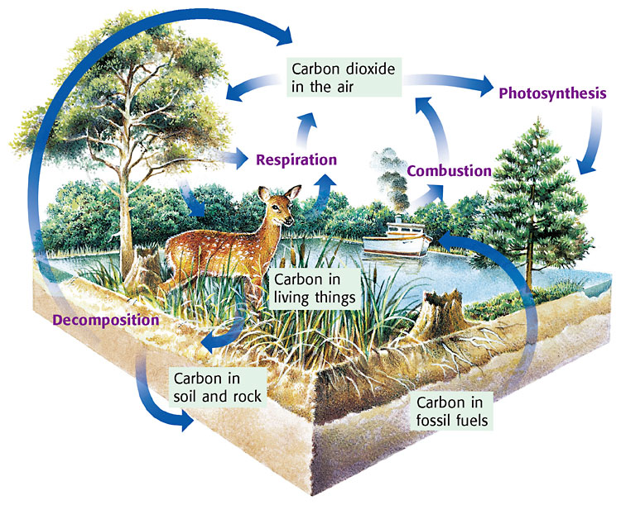

Draw a diagram of nitrogen cycling through organisms and their environment.
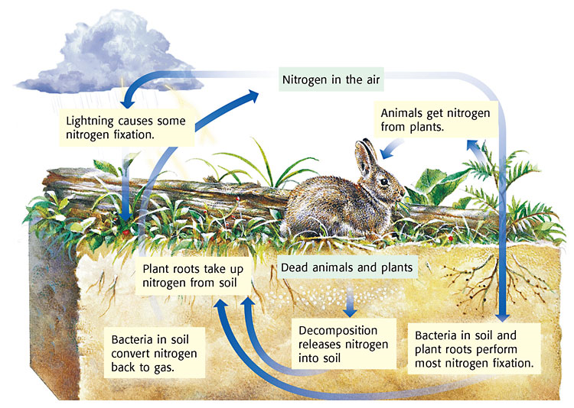

- Demonstrate understanding that energy originates from the Sun moves from organism to organism with in the food web.
Draw a diagram of the process of photosynthesis and cellular respiration. Explain the importance of photosynthesis and cellular respiration to living organisms. (Pg. 96/333)
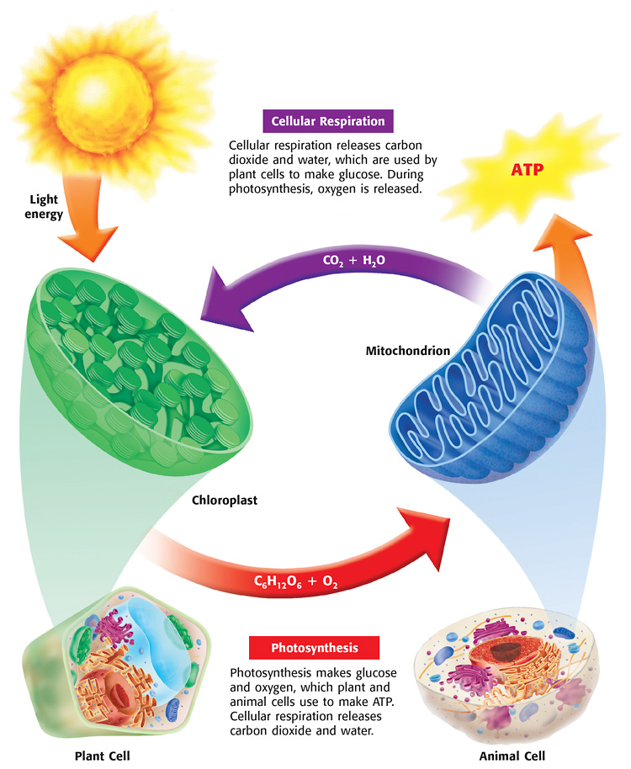

- Predict how changes in environmental conditions can affect the survival of both individuals and entire species. Pg. 488
Thanks to a reintroduction program, wolves are now back in Yellowstone after an absence of almost 70 years. Several dozen wolves were turned loose in Yellowstone in March 1995. These animals have done remarkably well, reproducing at a rapid rate. Packs are now located in various parts of the park. Wolves prey on a variety of species, notably elk in the Yellowstone area, but will also pursue moose, deer, sheep and other animals. Make some predictions about how the disappearance of wolves 70 years ago affected different species or individuals at Yellowstone. ANSWERS WILL VARY

- Categorize relationships between organisms that are competitive or mutually beneficial.
(Pg. 494)




PARASITISM MUTUALISM COMMENSALISM

Categorize the following:
- Mistletoe is a plant that takes nourishment from a tree, causing damage to the tree. parasitism
- Lichens benefit from living on a tree, but the tree is not harmed. commensalism
- Nitrogen-fixing bacteria get their nourishment from the roots of certain plants, providing the plants with nitrogen in return. mutualism
- Mice do well living near humans, living off the food scraps humans leave behind.commensalism
- Ticks are animals that attach to their hosts, feeding on the host’s blood. parasitism
- Aphids are insects that provide ants with a sweet liquid. Ants live alongside aphids, protecting them from predators. mutualism

6. List four characteristics for each of Earth’s major terrestrial and aquatic biomes. (Pg. 526-539)
Tropical Rain Forest | Savanna | Temperate  Deciduous Forest | Desert | Taiga  Coniferous Forest
Avg. Rain-up to 400cm | Avg. Rain-up to 150cm | Avg. Rain-75-125cm | Avg. Rain-less than 25cm | Avg. Rain-35-75cm
Avg. Temp. 20⁰C-34⁰C | Avg. Temp. 16⁰C-34⁰C | Avg. Temp. 6⁰C-28⁰C | Avg. Temp. 7⁰C-38⁰C | Avg. Temp. 14⁰C- -10⁰C
Trees form a canopy | Wet and dry season | Forest in layers | Very dry and very hot/cold | Has cone bearing trees
Most diversity of plants and animals | Large number of herbivores and herd animals | Trees shed leaves in winter | Animals and plants have special adaptations | Leaves adapted to conserve water
Tundra | Mountain/Alpine | Freshwater | Estuary | Marine
Avg. Rain-30-50cm | Avg. Rain-30-50cm | Littoral zone- near the edge | Where fresh and salt water meet | Intertidal Zone-  Near shore
Avg. Temp. 12⁰C- -26⁰C | Avg. Temp. 12⁰C- -26⁰C | Open-water zone-  As far as sunlight reaches | Salt concentration always changing | Neritic Zone-  Where ocean starts to slope
permafrost | permafrost | Deep-water zone-  No sunlight | Rich in nutrients | Oceanic Zone-  Open ocean
Herds migrate in and out of | Above the treeline | Brooks, rivers, streams, lakes | Supports plankton | Benthic Zone-  Deepest part

Evolution Pg. 164

Description: Evolution refers to understanding how organisms adapt to their environment over time and generations through natural selection, determining how natural selection affects the survival of species, and using the fossil record to study the evolution of life.
Evolution Background: In biology, evolution is the changes seen in the inherited traits of a population from one generation to the next. These changes are relatively minor from one generation to the next, but accumulate with each subsequent generation and can eventually cause substantial changes in the organisms. Inherited traits come from the genes that are passed on to offspring during reproduction. Mutations in genes can produce new or altered traits, resulting in the appearance of heritable differences between organisms. Evolution occurs when these heritable differences become more common or rare in a population, either non-randomly through natural selection or randomly through genetic drift.
- Explain how physical characteristics of organisms have changed over successive generations.
  - Darwin's finches are an excellent example of the way in which species' gene pools have adapted in order for long term survival via their offspring. The Darwin's Finches diagram below illustrates the way the finch has adapted to take advantage of feeding in different areas. Their beaks have evolved over time to be best suited to their function. For example, the finches that eat grubs have a thin extended beak to poke into holes in the ground and extract the grubs. Finches that eat buds and fruit would be less successful at doing this, while their claw like beaks can grind down their food and thus give them a selective advantage in circumstances where buds are the only real food source for finches.
A sudden shift in the continental shelf has created a large rift in the crust. This split in the crust separated a herd of zebras grazing in the area. One side shifted up in elevation causing temperatures to become much colder. The other side stayed at the same elevation causing no change in temperature. The two groups will remain isolated from each other for a million years. What differences in the two populations might you see after this time period?
ANSWERS WILL VARY
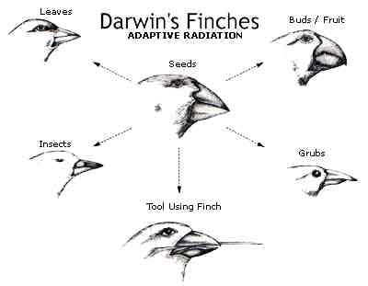

  - Peppered moths: Pollution, particularly in the 1800's, affected moth species because soot would collect on the sides of buildings and make them a darker color. The resultant effect was that the peppered moth, which had a light appearance, was more visible against the darker backgrounds of sooty buildings. This meant that predators of the peppered moth could find them more easily. Due to mutations, a new strain of peppered moth came to exist; their phenotype was darker than that of the white peppered moth. This meant that these new, darker peppered moths were once again harder to track down by their prey in environments where industry has taken its toll. In this instance, natural selection would favor the darker moths in polluted environments and the whiter moths in the lesser polluted environments due to their ability to merge in with their environmental colors and lessen the chances of them being prone to a predator.

- Demonstrate understanding of the processes of natural selection.
  - Overproduction: A fish may lay hundreds of eggs, but only a small number will survive to reach adulthood.
  - Variation: A mutation may cause a slight curve to develop in a fish’s tail.
  - Adaptation: The fish with the curved tail is able to swim more quickly and so escapes predators. The fish reproduces.
  - Selection: With each generation, more fish with a curved tail survive to reproduce. Over time, they make up a larger part of the group.
  - Special Note: If the salmon’s tail is curved by an accident (got stuck under a rock and tore off) than it is NOT a heritable trait and can not be passed down to the next generation. The variation must be coded in the organism’s genotype.
- Determine how the reproduction and survival of species is impacted by natural selection.
  - Mimicry: Some species copy other more harmful species as a survival method. Example: The harmless king snake mimics the colors of a deadly coral snake as a strategy to avoid predation.
  - Camouflage: Protective coloration allows a species to blend with its surroundings so perfectly that it is nearly invisible to a predator. Example: The leaf and thorn insects. (p. 358 in your textbook)
  - Venom: A harmful toxin produced by some organisms to make them distasteful or deadly to predators. Example: rattle snakes, poison ivy.
- __B____What does natural selection explain about a population?
a. how long it has been since it evolved
b. how it changes in response to its environment
c.how it resists change
d. how likely its members are to leave fossils
- __C____ Which individuals in a population are most likely to survive and reproduce?
a.the largest ones
b.the ones with the most DNA
c.the well-adapted ones
d.the oldest ones
- __C____ What theory explains how a population changes when the place it lives in changes?
a.adaptation
b.resistance
c.natural selection
d.speciation
- __B___ Besides surviving, what will the well-adapted members of a population do?
a.die out
b.reproduce
c.grow
d. hunt

.

